Physical Science Topics Lists

I. Safety; Equipment and Measurement; and Mass, Volume, and Density
Text: Introduction to Matter (Book K)
Test 1: Safety
- When you are finished with borrowed safety glasses, you return them to the cabinet for sanitizing.
2. DO NOT ask when you will be able to take off your safety glasses.
3. DO NOT eat or drink in the lab.
4. If a piece of equipment is not assigned to you, then DON’T touch it!
- If someone catches fire, wrap him in a fire blanket.
- After a lab, clean up the entire lab area and classroom and wash your hands.
- When using chemicals or glass, all students must wear closed-toed shoes and long pants. If you wear sandals, or shorts or a skirt, have old sneakers and long pants in your school (not phys ed) locker.
8-11: Use the diagram of the classroom below to match the safety equipment with its location.
8. Safety goggles—to the right of the exit
9. Fire extinguisher—by the prep room door
10. Eyewash/shower station/fire blanket—to the left of the exit.
11. Aprons—back left corner of the room as you look from the front

Test 2: Equipment and Measurement

Measuring with a scale and units:

A scale is a series of lines and numbers used to read measurements. Each scale measures in “units,” like inches or centimeters. The units are as important as the numbers are.
Many of the measuring tools used in the science lab have scales on them. When you measure using a scale of any kind, you use the numbers to figure out what the lines stand for. Only then can you determine the measurement and label with units.

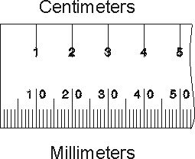

- Ruler/Meterstick

The ruler is used to measure length in millimeters or centimeters. Make sure to determine whether zero is at the edge of the ruler or set away from the edge. Start your measurement from zero, wherever it is.

- Beam Balance

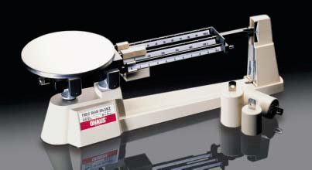

The beam balance is used to measure mass of an object or substance in grams. See the accompanying page that explains how to use the beam balance.

3. Graduated Cylinder

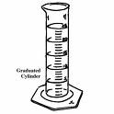
The graduated cylinder is used to measure the volume of liquids in milliliters. See the accompanying page that explains how to read the graduated cylinder. The glass graduated cylinder is delicate and can tip over easily.

- Thermometer

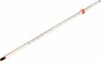

The lab thermometer is used to measure the temperature of objects or substances using the Celsius scale. The thermometer measures the temperature of whatever the bulb (red end) is touching. The thermometer may have a Fahrenheit scale as well. The thermometer is delicate, especially the bulb. Don’t leave thermometers standing up in containers, use a clamp!

Reading a Graduated Cylinder

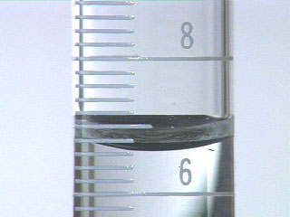
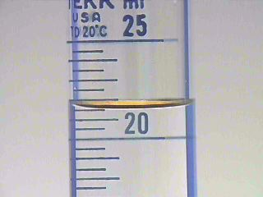
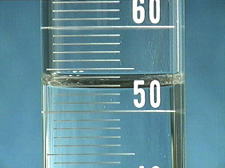
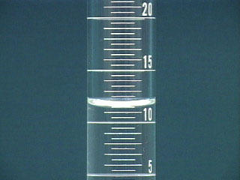
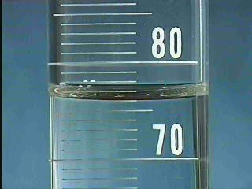
- Measure from the lowest part of the water’s curved surface, in the middle, called the meniscus.
- Identify the nearest numbers.
- Identify the value of each line.
- If the meniscus is right on a line, that’s the measurement.
- If the meniscus is between lines, round to the nearest line.

First (above): Between 6 and 8 are ten lines, so each line counts for two tenths. The big line in the middle is seven. The meniscus is right on the third line from the top, so it is 6.6ml.

Second: Between 20 and 25 there are 10 lines, so each counts for .5 or ½. The longer lines are the ones while the shorter lines are the halves. The meniscus is right on the third line, so it is 21.5ml.

Third: Between 50 and 60 are 10 lines, so each line counts for 1. The meniscus is closest to the third line, so it is 53ml.

Fourth: Between10 and 15 are 10 lines, so each line counts for .5 or ½. The meniscus is right on the third line, so it is 11.5ml.

Fifth: There are 10 lines between 70 and 80, so each line counts for one. The larger line between is for 5. The meniscus is on the sixth line, so it is 76ml.

Using a Beam Balance

A beam balance measures mass in grams. Spring scales measure weight. The balance is able to measure mass without regard to gravity because it compares the weight of the scale weights and the weight of the object being weighed. Since gravity acts the same on both, it can be ignored, making the resulting measurement one of mass not weight.

Directions:
- Slide all three weights to zero (as far to the left as they can go)

- Check the “zero” line at the far right. If the white line on the black pointer aligns with the white line to the left of the zero, then the balance is adjusted properly. If the lines do not match, then the balance must be adjusted (tared). Adjustments are made by twisting the silver knob at the far left-hand side of the balance until the two white lines match. The balance is now adjusted.

- Place the object to be massed in the center of the flat pan at the left. Start by moving the largest weight first (500g center beam). Move it right one notch at a time until the balance arm rocks down. Then move it back one notch left. Repeat this procedure with the 100 g beam next. Finally, get the zero lines to match by sliding the weight on the fine measurement beam (10g) to the right. When the zero lines match, add up the mass in grams of all three beams. The resulting sum is the mass of your object.

- If you are measuring a granular or powdered substance, put a paper on the pan before adding the substance. If you are measuring a liquid, measure the liquid in a beaker or graduate. Measure and subtract the mass of the paper or liquid container from the total mass to get the mass of the substance.

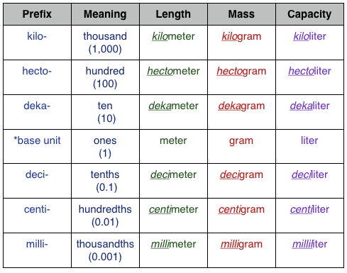
Test 3: Matter: Mass, Volume, and Density (Introduction to Matter (K) 1-1 p. 4-9)
1The observable universe consists of matter and energy existing in spacetime. Energy and matter, though distinct, are equivalent in that they can be changed into one another. Examples of energy include movement, sound, visible and invisible light, and stored or potential energy.
2Two objects may not occupy the same space at the same time.
3Volume is an amount of three-dimensional space.
4Fluid (liquid or gas) volume is customarily measured with liters, milliliters, etc., while solid volume is customarily measured with cubic length units such as cubic centimeters (cc’s) or cubic meters. Liquid volume is measured with a graduated cylinder. One cubic centimeter is equal in volume to one milliliter.
5Matter may be thought of as “stuff,” and has mass and volume.
6The volume of regular objects may be calculated with measurements and formulas while the volume of irregular objects may be calculated using the water displacement method.
7The volume of a cube may be calculated by multiplying lengthxwidthxheight. You need to be able to calculate the volume of a cube given its dimensions.
8Mass is the amount of matter in an object and doesn’t change unless matter is added to or taken away from the object. Weight is the force of gravity pulling on an object and will change if mass or gravity changes.
9A spring scale is used to measure weight while a balance is used to measure mass.
10Weight units are newtons while mass units are grams, kilograms, etc.
11Density is the relationship between an object’s mass and volume, or how “heavy” an object is for its size.
12Low density: Styrofoam, balsa wood, most gases/ High density: Lead, steel, granite
13Water has a density of 1 g/ml.
14Density controls buoyancy(floating). A less dense object will float in a more dense fluid. A more dense object will sink in a less dense fluid. An object whose density is equal to the density of the fluid it is in will suspend or hang in the middle of the fluid neither sinking nor floating.
15Mathematically: Density = Mass / Volume (density equals mass divided by volume)
16Be able to use it to calculate the density of an object give its mass and volume.
II. Physics: “What makes objects move the way they do?”

Physics Topics Lists (Study Guides) 1-7 Text: Forces, Motion, and Energy (BOOK M)

Test 1: Force and Motion (1-1, 1-2)

- Motion is an object’s change in position relative to a reference point.
- A reference point or point of reference is an object that appears to stay in place as another object moves. It is necessary to observe motion.
- Average speed is total distance/total time. Be able to calculate average speed given distance and time.
- Instantaneous speed is an objects speed at a particular moment, or instant.
- The difference between speed and velocity is that speed is just how fast something goes while velocity is how fast something goes in a certain direction. Speed is a “scalar” that shows only how fast an object is going while velocity is a “vector” that indicates the rate at which an object changes position. Speed has only a magnitude or size while velocity has both a magnitude and a direction.
- A scalar is a measurement that has only a size or magnitude while a vector is a measurement with both a size or magnitude and a direction. Given examples of measurements, be able to classify them as scalars or vectors.
- Acceleration is the rate at which velocity changes.
- Be able to draw, read, and analyze speed graphs (distance v time). Know what constant speed and changing speed look like on speed graphs.(p.5)
- Be able to analyze acceleration graphs.(p.8)
- Circular motion is constant acceleration because you are always changing direction so the velocity is always changing.
- A force is a push or pull on an object that has both a size and direction.
- Net force is the combination of forces acting on an object. Forces in the same direction are added while forces in opposite directions are subtracted. You should be able to use net force to determine the direction that an object will move.
- Unbalanced forces cause changes to objects’ motions.
- Balanced forces cause no changes to objects’ motions.

Test 2: Friction and Slipping and Sliding Lab (1-3)

Friction
1Friction is a force (N) that opposes motion between surfaces that are in contact.
2Friction occurs among all the different states of matter including liquids and gases.
3Friction can be either kinetic or static.
4Static friction occurs when the object is not moving.
5Kinetic friction occurs when the object is moving.
6Rolling
7Sliding
8Fluid

9Friction is caused when hills and valleys of solid surfaces touch each other and stick.

10The amount of friction between two surfaces depends on many factors.
11The greater the force pushing the surfaces together, the greater the friction
12The more rough the surfaces, the greater the friction

13Friction can be both helpful and harmful.
14Know some examples of how it is helpful and harmful.

15The force of friction can be increased or decreased.
16Friction may be reduced by lubricants, changing from sliding to rolling, and smoothing surfaces.
17Friction may be increased by roughening surfaces or increasing the force pushing them together.

Shipping and Sliding Lab
18Given a description of an experiment, be able to recognize sources of error:
19failure to keep constant variables constant
20failure to match the experimental design to the problem or question
21failure to conduct multiple trials

22Given a data table from an experiment, be able analyze data:
20to answer the experimental problem or question or recognize that the data are inconclusive
24to critique someone else’s data analysis

25Given an inquiry task be able to identify the following:
26question
27independent variable
28dependent variable
29constant variables

Test 3: Gravity and Motion (1-4, 2-1)

The Law of Universal Gravitation:

1Gravity is a pulling force that attracts all objects to each other.
2The greater the masses of the objects, the greater the gravitational force
3The greater the distance between the objects, the less the gravitational force

4Compare and Contrast mass and weight

5Mass is the amount of matter in an object.
6measured with a beam balance in units of grams
7does not depend on gravity or location

8Weight is the pulling force of gravity on an object.
9measured with a spring scale in units of Newtons
10depends on gravity and location.

11Falling Objects—Gravity and Air Resistance

12All objects accelerate toward earth at the same rate (9.8 m/s/s)

13Air resistance is the force that opposes the motion of an object through air.
14Air resistance is fluid friction between the moving object and the molecules of air that it is passing through.
15The amount of air resistance on a moving object depends on the object’s size, shape, and speed
16Terminal velocity occurs when the force of air resistance equals the force of gravity. Acceleration stops when the forces balance.
17Free fall is when an object falls without air resistance, as in orbit.

Orbit—Inertia and Centripetal Force
18Orbit is the circular motion of one object around another object in space.
19Two motions combine to form orbit: inertia(forward motion) and free fall
20Centripetal force is the unbalanced force that causes orbiting objects to move in a circle.
21Gravity provides the centripetal force that keeps objects in orbit.

Projectile Motion

22Projectile motion is the curved path that an object follows when it is thrown or propelled near the surface of the earth.

23Projectile motion has two independent/unrelated parts, horizontal and vertical motion.

Test 4:Newton’s Laws (2-2)

24Newton’s First Law: Objects tend to resist changes to their motions. (Inertia)
25An object that is not moving will not move unless acted upon by an unbalanced force.
26An object that is moving will continue to move at the same speed and in the same direction (velocity) unless acted upon by an unbalanced force.
27Balanced forces do not cause changes to an object’s motion.

28Newton’s Second Law: The acceleration of an object depends on its mass and the force
applied to it.
29Acceleration equals applied force divided by mass of object. (A=F/M)
30Given the mass of an object and the force applied to it, be able to calculate its acceleration in m/s/s using the formula.
31The greater the force, the greater the acceleration.
32The greater the mass, the less the acceleration.
33Be able to explain how a change to force or mass changes acceleration.

34Newton’s Third Law: Forces act in pairs.
35If a force is exerted, another force occurs that is equal in size and opposite in direction.
36Action and reaction force pairs are present in moving and non-moving objects.

Test 5: Work and Machines (Chapter 4)

Section 1: Work(4-1)

1Work is when a force causes an object to move in the direction of the force.
2Work=ForcexDistance. Be able to calculate work given force and distance.
3Work is a scalar, measured in joules (Newton-meters), a unit of energy
4Force is a vector, measured in Newtons
5Distance is a scalar, measured in meters

Section 2: What is a Machine?(4-2)

6A machine is a device that makes work easier by changing the size or direction of force.
7Work input is the work done on a machine (often by a person)
8Work output is the work done by a machine (on another object)
9Input force is the force put on a machine (often by a person)
10Output force is the force that the machine applies to another object.

11The force-distance Tradeoff: machines can change the relationship between input and output force and distance.

12Force multipliers: Some machines increase the input distance to decrease the input force. They make it possible to exert greater force on an object over a shorter distance. These machines make it possible for us to lift heavy things or crush tough objects.
Examples: ramp, nutcracker, wheel barrow

13Distance and speed multipliers: Some machines increase the input force to decrease the input distance. They make it possible to move an object a greater distance and speed. These machines make it possible for us to generate faster speeds by covering greater distances in a given time.
Examples: Lacrosse stick, baseball bat, hammer

14Mechanical advantage is the number of times a machine multiplies force. It compares the input and output forces.
15MA= output force/input force
16Be able to calculate mechanical advantage given output force and input force.

17Mechanical efficiency compares a machine’s work output with its work input. It answers the question, “how much work makes it through the machine and how much work is lost due to friction in the machine?”
18ME=work output/work inputx100%. Be able to calculate mechanical efficiency given work output and work input.

19The work output of a machine is always less than the work input of a machine because of energy lost due to friction, so no machine can have a mechanical efficiency of 100%.

Section 3: Types of Machines(4-3)

Lever, pulley, wedge, screw, wheel and axle, inclined plane
20Be able to identify and give examples of six simple machines.
21Be able to analyze the mechanical advantage of each simple machine.
22Be able to recognize machine families: “Wheel is a circular lever while pulley is a grooved wheel. Wedge is a moving inclined plane while screw is an inclined plane wrapped around a cylinder.”

Levers: (107-8)

Lever Class | Input, Fulcrum, and Load-Output locations | Direction change | Force distance tradeoff | Mechanical Advantage
First | I-F-LO | yes | variable | variable
Second | F-LO-I | no | Force multiplier | >1
Third | F-I-LO | no | Distance/speed multiplier | <1

23First class lever: Input, Fulcrum, Load-output
Changes the direction of force. May be a force or distance multiplier or neither. Mechanical advantage is variable.
24Second class lever: Fulcrum, Load-output, Input. Does not change the direction of the force. Force multiplier. Mechanical advantage is greater than 1.
25Third class lever: Fulcrum, Input, Load-output. Does not change the direction of force. Distance/speed multiplier. Mechanical advantage is less than 1.

Pulleys(108): a grooved wheel with a rope or cable
26Fixed pulley is a single pulley that only spins, so it changes only direction, not force. MA=1
27Movable pulley is a single pulley that spins and moves up with the load-output as it is lifted. It is a force multiplier, MA=2.
28Block and tackle is 4 pulleys with four rope segments running among them. It is a force multiplier, MA=4.

29Compound machine (112) is a machine made up of two or more simple machines working together. Given an example of a compound machine, be able to identify the simple machines that make it up.

Test: 6 Energy

What is Energy(5-1)
1Energy is the ability to do work.
2expressed in units of joules (J)
3when one object does work on another, the energy is transferred from the first object to the second object.
There are many different forms of energy:
4Kinetic energy | Energy of motion
5Potential energy | Stored energy or energy due to an object’s position
Mechanical energy | the sum of an object’s kinetic and potential energy
6Thermal energy | the energy of an object’s moving particles (atoms and molecules); it is related to but different from heat and temperature
7Sound energy | the energy of vibrations traveling in waves through matter
8Nuclear fission energy | comes from changes to the atom’s nucleus: when the nucleus of an atom divides
9Nuclear Fusion energy | comes from changes to the atom’s nucleus: when two or more nuclei join together
10Electrical energy | the energy of moving electrons being pushed or pulled by electromagnetic force
11Chemical energy | the energy contained in the bonds among atoms and molecules. It changes as the bonds change.
12Light energy | produced by the vibrations of charged particles; it moves in waves and doesn’t need matter to move; its characteristics depend on the wavelengths; it can be invisible or visible.

13Potential energy is stored energy that an object has because of its shape position.

14Be able to calculate gravitational potential energy:
15GPE = weight x height
16Unit label is newton-meters or joules (J)

17Kinetic energy is the energy of an object due to its motion. It depends on mass and speed, but speed matters more than mass does.
18Given mass and velocity, be able to calculate an object’s KE:
19KE = ½ mv²
20Unit label is joules

21The PE or KE of an object can increase or decrease, but the total energy of an object (ME) remains the same unless it transfers some of its energy to another object.

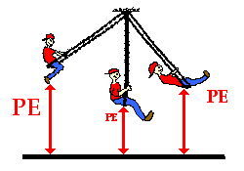
Ex:
- When the child is pulled back at the highest point on the swing, the ME is PE.
- As the child swings forward toward the lower (middle) part of the wing, the child accelerates and gains KE, but due to the height position the PE of the child decreases.
- Child continues to swing upward and slows down as KE decreases, but the height and PE increase.
- The child reaches the highest point of the swing and the ME is PE.

22The Law of Conservation of Energy is that energy may change form, but it cannot be created or destroyed. (The total amount of energy remains constant.)

23Energy Conversions are when energy changes from one form to another.
- Any form of energy can change into any other form(s) of energy.

Energy Conversions(5-2)
24Given a real world situation that we have not previously discussed, be able to describe and explain the energy transformations that are occurring in it.
Energy conversion example: Swingset
With every pass of the swing, friction and air resistance are unbalanced forces which cause some of the ME of the swing to change to thermal energy (heat).
Energy conversion in plants: Nuclear fusion in the sun produces light energy that travels through space until it reaches the leaves of plants on earth. The plant leaves absorb the light energy from the sun. They use the light energy along with chlorophyll to turn CO₂ and H₂O into sugar which stores the sun’s energy chemically.
Energy conversions in the human body:
- Every time you move your hand you rely on the conversion of stored PE to KE on your hand as you do work on it.
- Some of the stored PE in your body is used to maintain constant internal body temperature. Some of the stored PE is also converted to excess heat your body gives off to its surroundings.
- In your body stored energy is found in fat and is lost when work is done or when heat is lost by your body to its surroundings.
- To stay healthy you need a proper balance between energy taken in and energy lost from your body as work or heat.
- Food is our chemical potential energy
Your body chemically changes food into molecules that can combine with oxygen and be used as fuel. Your body converts energy stored in fats for its immediate needs until you eat. We get energy (Calories) from food.
The energy from food allows us to maintain constant body temperature, helps organs function, allows us to move and do work.
Test 7: Bridge Basics

Bridges can be designed in different ways and from different materials to withstand certain loads and potentially destructive forces.
- Bridges are elevated structures designed to support the movement of objects over a span. Span can describe the distance the bridge covers or the unsupported distance between supports or piers that are attached to the ground. Bridges must support their own weight (dead load) and the weight of those objects that will cross over them or other forces that will act on them from time to time, such as wind, snow and ice (live load). Bridges are kept stable by balancing the load forces with the supporting forces of the structure. These forces can cause parts of the bridge structure to push together (compression) or pull apart (tension).
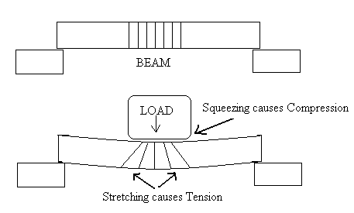

- Different bridge designs distribute tension and compression forces in different ways, depending on the shapes of the parts of the structure. The biggest difference among bridge designs is the distances they can cross in a single span. Shapes commonly used in bridge design include arches, triangles and rectangles.
- Bridges are constructed of different materials whose properties and costs vary. Some materials are strong against compression forces but weak against tension forces; some materials resist fire, corrosion or weathering. Materials commonly used in bridge design include wood, rope, aluminum, concrete and steel.
- A beam bridge balances the load by concentrating it entirely onto the two piers that support the bridge at either end, or sometimes on piers distributed throughout the span. When a force pushes down on the beam, the beam bends. Its top edge is pushed together (compression), and its bottom edge is pulled apart (tension). The amount of bend depends on the length of the beam. Beam bridges are cheap and simple, but they can only span short distances unsupported.

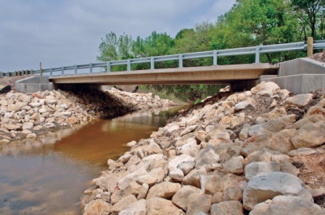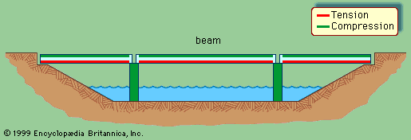

- A truss bridge is a beam bridge with extra supports above the main beams. It uses rigid, interlocking members to form a system of triangles that distribute the load among all parts of the structure, increasing the structural strength of the bridge. Truss bridges can span longer distances than beam bridges can because the trusses support the beams.
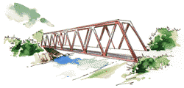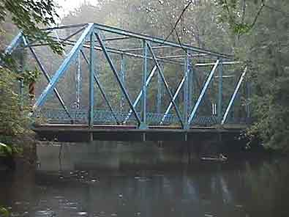

- A suspension bridge or cable-stayed bridge uses cables (steel ropes) suspended from tall towers to hold up the deck and distribute the load. The tension and compression forces acting on the beam are distributed among the cables ( tension) and the towers (compression).
The suspension bridge has two sets of cables: a pair of thicker cables that runs horizontally and is attached to the towers and the land at the ends of the bridge and a thinner set of many cables that hangs the bridge from the thicker set. The cable-stayed bridge has only one set of cables that attach the deck directly to the towers. Suspension and cable stayed bridges can span the longest distances.


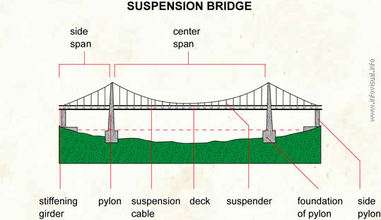
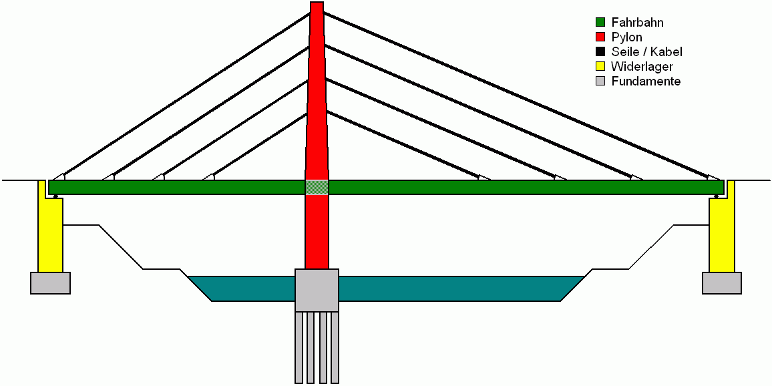

- Engineers build models of bridges, conduct controlled experiments to learn how they will withstand various stresses, and consider the benefits and trade-offs of various design alternatives.
- Bridge design is influenced by the length of the span, the properties of the materials, and environmental conditions, as well as by practical considerations, such as the bridge’s appearance, cost of materials or construction site challenges.
- Bridges can fail because they have faulty parts, are used in ways that exceed what was intended by the design, or were poorly designed to begin with. Most commonly, bridges fail because they have been poorly maintained—rusted steel or cracking concrete piers.
III. Chemistry: “How does the structure of matter affect the properties of materials?”
Text: Introduction to Matter (Book K)

Test 1: Physical, Chemical, and States of Matter (1-2, 1-3,2-1)
1Know and be able to describe the 6 physical properties pictured on page 11 of the textbook.
2Be able to classify properties as physical or chemical.
3Be able to classify changes as physical or chemical.
4Physical changes change the shape or form of the object or material without changing it into a new substance while chemical changes change the identity of one or more substances so that a new substance is formed.
5Physical properties are those properties that can be observed without making new substances. Examples include state, density, color, and hardness. Chemical properties describe the ability of a substance to change into another substance or substances. Chemical properties may only be observed by changing or trying to change the substance into a new substance.
6Recognize the signs of chemical change shown and described on pages 18-19 of the textbook.
7A characteristic property is a physical or chemical property that does not depend on the quantity (mass or volume) of the substance—useful in identifying and classifying substances. (p.17)
 | Solid | Liquid | Gas
Particle spacing | very close together | almost as close as solid | spread out
Particle speed | slowest | medium | very fast
Particle interaction | particles locked in place, vibrating | Particles stay together but slide past one another to change locations | Particles touch/interact very little
Balance of forces | Attraction among molecules overwhelms particle energy | Attractive and particle energy are somewhat balanced | Particle energy overwhelms attraction among molecules
Volume | definite | definite | Indefinite—may be compressed or expanded
Shape | definite | Indefinite—takes the shape of the container | Indefinite—takes the shape of the container
8Be able to describe solids, liquids, and gases in terms of their volume and shape. Be able to identify examples of the different states.

9Be able to describe solids, liquids, and gases in terms of the spacing and speed of their particles.
10States of matter are determined by a balance of forces among the particles. The particles’ energies (temperature) cause them to move around and spread apart while the attractive forces among particles cause them to stick together. How these forces balance out determines the state of matter.
Test 2: Atoms (CH4)
State Standard: Describe the structure of the atom and its component parts.
- Scientific theories change over time to explain new data.
- Models are useful for understanding the natural world, but they can be misleading.
- The atom is composed mostly of empty space.
- Matter in the atom is protons, neutrons, and electrons.
- Protons are dense positively charged particles in the nucleus.
- Neutrons are dense uncharged particles in the nucleus.
- Electrons are much smaller negatively charged particles that whirl around the nucleus as bees whirl around a hive.
- An atom is identified as an element by the number of protons.
- Ion: when an atom has a more or fewer electrons than protons. More electrons gives it a negative charge while fewer electrons gives it a positive charge.
- Isotope: atoms of a substance that have different numbers of neutrons, and therefore, different mass numbers/atomic masses.
- Gravity is a force that draws all matter to all other matter. Its strength depends on mass and distance.
- Electromagnetic force is the force that attracts protons to electrons and repels protons from protons and repels electrons from electrons. The terms positive and negative are used to describe the charges, and it is the force that causes electricity and magnetism.
- Strong force is the force that holds nuclear particles together.

Particle | Charge | Location | Mass
Proton | + (positive) | nucleus | 1 amu
Neutron | 0 (uncharged) | nucleus | 1 amu
Electron | - (negative) | Orbit/cloud outside nucleus | 0 amu (very much less than 1 amu)

Test 3: Elements and the Periodic Table (CH 3 sec 1, CH 5 sec 1)
P.106-113&56-59
Table of Common Elements and their Properties
* denotes elements explicitly mentioned in the state standards.
Element | Symbol | Class | State | Physical prop | Chemical prop
Oxygen* | O | Nonmetal | Gas | Colorless, odorless | Reactive, causes combustion
Hydrogen* | H | Nonmetal | Gas | Low density, colorless, odorless | Highly reactive
Nitrogen | N | Nonmetal | Gas | Colorless, odorless | Less reactive than oxygen or hydrogen
Helium | He | Nonmetal | Gas | Low density, colorless, odorless | Non-reactive noble gas
Chlorine | Cl | Nonmetal | Gas | Green, strong odor | Highly reactive with hydrogen and metals, poisonous
Carbon* | C | Nonmetal | Solid | Varied:diamond, hard, shiny, clear, crystalline Graphite: soft, black | Reactive with oxygen, important in the compounds found in living things
Iron* | Fe | Metal | Solid | Moderate/high density, dull silver color, hard | Reacts with oxygen to form rust
Aluminum* | Al | Metal | Solid | Low density, dull silver color, softer than iron | Less reactive than iron and many other metals
Lead | Pb | Metal | Solid | High density, dull silver color, very soft | Poisonous, combines easily with oxygen

1Element: a pure substance that cannot be broken down chemically into simpler substances.
2Metals: Mostly solids, shiny, good conductors, malleable and ductile
3Metalloids/Semimetals: Some shiny, some dull, somewhat malleable and ductile, some are good conductors, some semiconductors
4Nonmetals: Solids are dull, brittle, and poor conductors; gases are nonmetals
5Pure substance: Made up of only one type of particle; includes elements and compounds
6Elements are pure substances because each is made up of only one kind of atom.
Characteristic property: may be used to identify a substance; doesn’t depend on quantity of the sample
7The periodic table is organized in the following way:
- Atomic number: each element goes up by one proton as you move across a period.
- Periods: Horizontal rows; properties such as reactivity and conductivity change gradually as you move across a period, so period neighbors have similar properties
- Groups: Vertical columns; elements have similar chemical or physical properties to their group neighbors (elements in the same column)

8Be able to use a periodic table to identify the elements in a compound by their symbols.
9Be able to use the periodic table to locate metals, semimetals/metalloids, and nonmetals:
10Metals are left and middle, non metals are in the top right corner, and metalloids are between metals and non-metals.

Test 4: Compounds and Mixtures (CH 3 sec 2,3)
Compounds
1The properties of compounds are usually very different from the properties of the elements that make them up.
2Atoms of elements bond together to form molecules of compounds. The bonding happens so that atoms may share electrons to fill their outer shells (create a stable electron configuration).
3A compound, like an element, is a pure substance.
4Be able to analyze the chemical formula of a compound to tell how many atoms of each element it contains. C₆H₁₂O₆ contains 6 carbons, 12 hydrogens, and 6 oxygens, 24 atoms total.

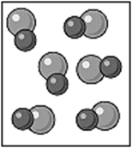

Mixtures
5Be able to contrast a mixture with a compound (p.66 table 1)
6Mixture: Made of elements, compounds, or both; the substances keep their properties; may be separated by physical means, formed by any ratio of substances
7Compound: Made of elements; substances change their properties; may only be separated by chemical means; formed by a set ratio of substances
8Be able to classify mixtures as solutions, colloids, or suspensions using their properties (see table below).

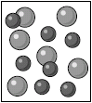

Solution | Colloid | Suspension
Smallest particles, molecules/atoms/ions | Larger particles but still very small | Largest particles
Appears uniform like a pure substance. Doesn’t scatter light (not cloudy) | Scatters light. Cloudy. | Scatters light. Cloudy.
Particles too small to settle out. | Particles too small to settle out. | Particles settle out.
Cannot be filtered | Cannot be filtered | Can be filtered
Saltwater, sugar syrup, steel, carbonated water | Jello, milk, mayonnaise | Snow globe, muddy water, anything that you have to shake before using.

9Be able to explain how physical means, such as boiling/evaporating, sifting/filtering, magnetism, density, hand sorting, and solubility, may be used to separate mixtures. (p 65).
10Know the definition of solvent, solute, solubility, and concentration.
11Know the factors that affect how solids and gases dissolve in liquid solvents: heating/cooling, crushing, stirring, mixing. (p. 69)

