Bridge Basics

Bridges can be designed in different ways and from different materials to withstand certain loads and potentially destructive forces.

- Bridges are elevated structures designed to support the movement of objects over a span. Two important forces at work in bridges are tension and compression.

- Bridges must support their own weight (dead load) and the weight of those objects that will cross over them or act on them from time to time, such as wind, snow and ice (live load). Bridges are kept stable by balancing the load forces with the supporting forces of the structure. These forces can cause parts of the bridge structure to push together (compression) or pull apart (tension).
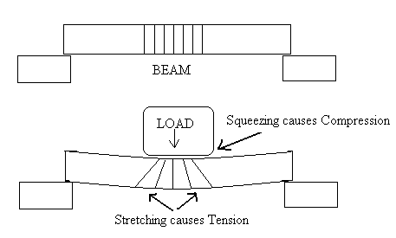

- Different bridge designs distribute tension and compression forces in different ways, depending on the shapes of the parts of the structure. The biggest difference among bridge designs is the distances they can cross in a single span. Shapes commonly used in bridge design include arches, triangles and rectangles.

- Bridges are constructed of different materials whose properties and costs vary. Some materials are strong against compression forces but weak against tension forces; some materials resist fire, corrosion or weathering. Materials commonly used in bridge design include wood, rope, aluminum, concrete and steel.

- A beam bridge balances the load by concentrating it entirely onto the two piers that support the bridge at either end. When a force pushes down on the beam, the beam bends. Its top edge is pushed together (compression), and its bottom edge is pulled apart (tension). The amount of bend depends on the length of the beam.

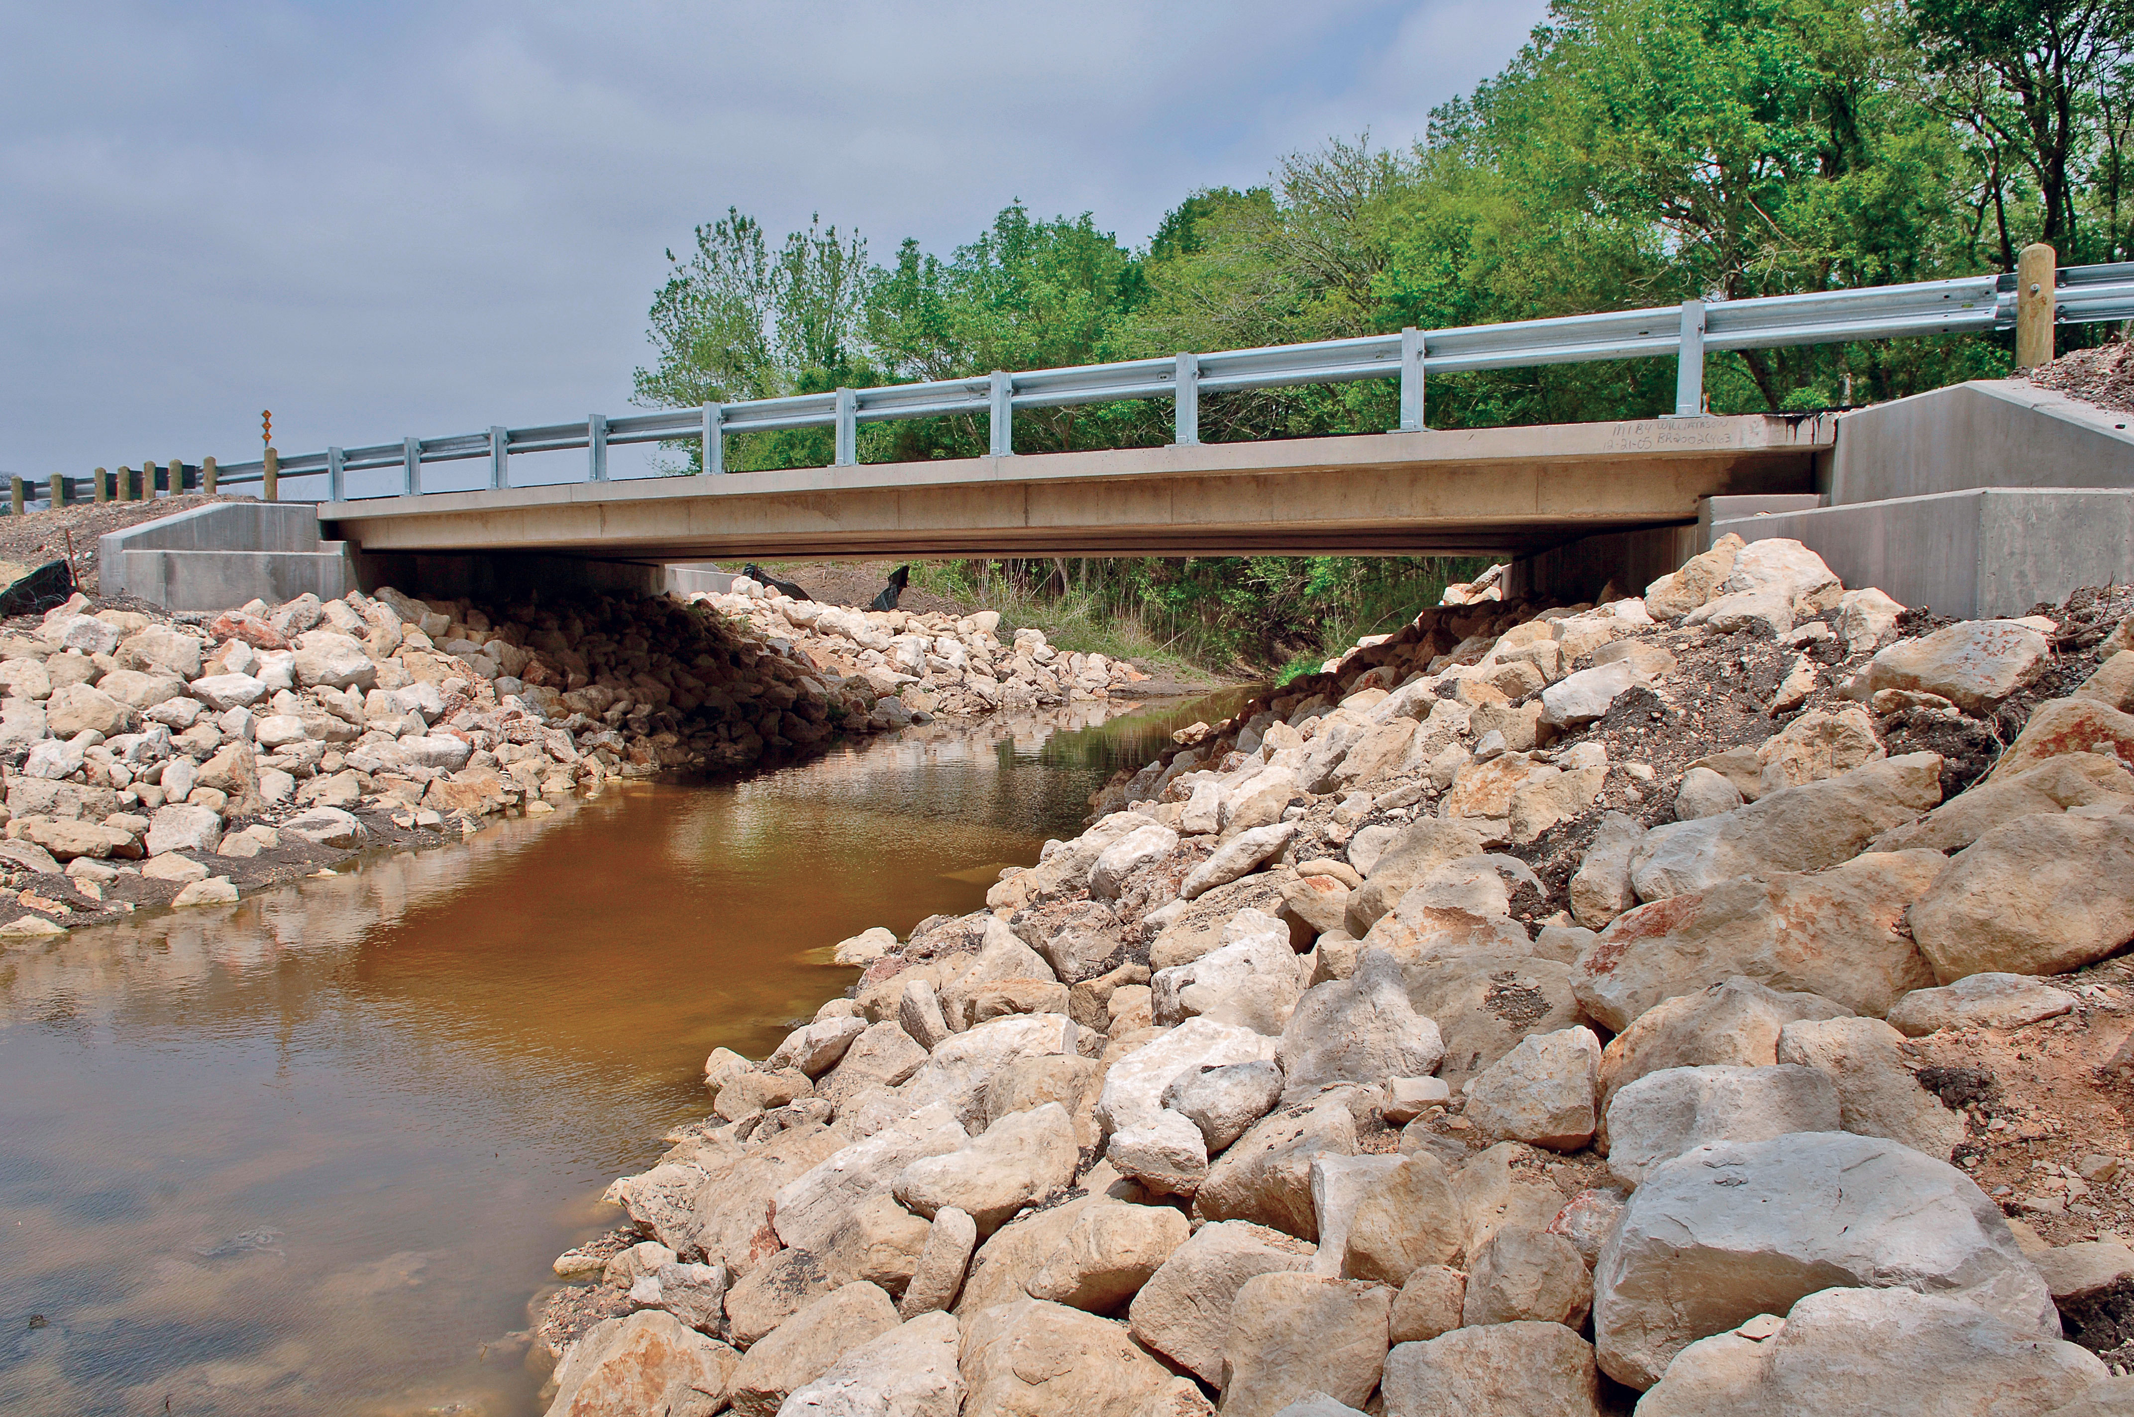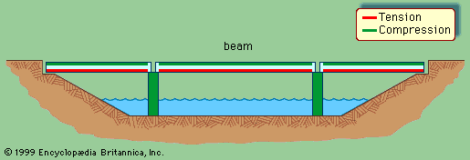

- A truss bridge uses rigid, interlocking beams to form a system of triangles that distribute the load among all parts of the structure, increasing the structural strength of the bridge.
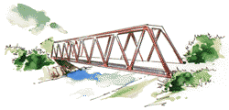

- A suspension bridge uses cables suspended from tall towers to hold up the deck and distribute the load. The tension and compression forces acting on the beam are distributed among the cables (which experience tension) and the towers (which experience compression).
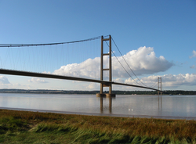

- Engineers and scientists build models of bridges, conduct controlled experiments to learn how they will withstand various stresses, and consider the benefits and trade-offs of various design alternatives.
- Bridge design is influenced by the length of the span, the properties of the materials and the environmental conditions, as well as by practical considerations, such as the bridge’s appearance, cost of materials or construction site challenges.
- Bridges can fail because they have faulty parts, are used in ways that exceed what was intended by the design, or were poorly designed to begin with.

