Chapter 2- Section 2
Scientific Method in Earth Science

Learning about the Natural World
- Asking questions is the beginning process of the scientific method
What are Scientific Methods?
Scientific Method- Series of steps followed to solve problems
- It is not a set procedure; you may or may not use all the steps
- The goal is to gain insight and come up with reliable answers/solutions.
Ask a Question
- The purpose of asking a question is to focus the investigation
Form a Hypothesis
Hypothesis – an explanation that is based on prior scientific research of observations that can be tested.
- A hypothesis is formed when a scientist wants to investigate a question
- It is testable!

Test the Hypothesis
- Scientists test hypothesis by gathering data. Helps tell whether or not a hypothesis is valid or not.
Controlled Experiments
- To test the hypothesis, scientists must do a controlled experiment
- Controlled experiment – tests only one factor
- Variable is a factor that changes in an experiment to test hypothesis.
- It is important for scientists to be able to change just one variable because scientists can see results of just that one change.
Making Observations
- At times, observations are more important than doing experiments
Keeping Accurate Record
- Need to have accurate and clear records of data
- No opinions
- It is also important for scientists to repeat experiments to verify findings.

Analyze the Results
- Happens after testing
- Two common ways scientists organize and summarize their data is by making tables and graphs.
- 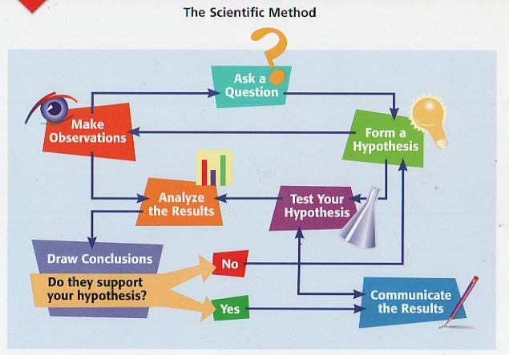
Draw Conclusions
- After analyzing the results, scientists determine if results support the hypothesis
- Results are valuable even if doesn’t support hypothesis
- Repeat experiment/investigation if necessary or ask new questions or form new hypothesis.

Communicate Results
- It is important to share results with others because other scientists evaluate experiment and science depends on sharing of information.
- Scientists share results by writing reports for scientific journals or give lectures.
- If there is new evidence, other scientists may do further testing.

Case Closed
- New evidence may come available after results are accepted
- Scientists may have more questions to test

