Chapter 2- Section 2
Scientific Method in Earth Science

Learning about the Natural World
- Asking questions is the beginning process of the scientific method
What are Scientific Methods?
Scientific Method- __________________________________________________________________________________________________________________________________________________________
- It is not a set procedure; you may or may not use all the steps
- The goal is ________________________________________________________________________
Ask a Question
- The purpose of asking a question is to ________________________________________________________________________
Form a Hypothesis
Hypothesis __________________________________________________________________________________________________________________________________________________________
- A hypothesis is formed when a scientist wants to investigate a question
- It is testable!

Test the Hypothesis

Controlled Experiments
- To test the hypothesis, scientists must do a controlled experiment
- Controlled experiment is ________________________________________________________________________________________________________________________________________________
- Variable is ________________________________________________________________________
- It is important for scientists to be able to change just one variable because ________________________________________________________________________________________________________________________________________________

Making Observations
- At times, observations are more important than doing experiments
Keeping Accurate Record
- Need to have accurate and clear records of data
- No opinions
- It is also important for scientists to ________________________________________________________________________________________________________________________________________________

Analyze the Results
- Happens after testing
- Two common ways scientists organize and summarize their data is by making ________________________________________________________________________
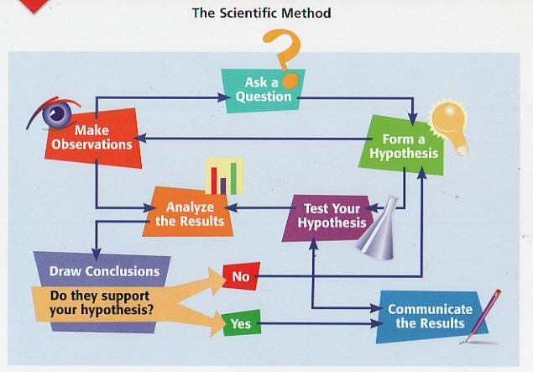
Draw Conclusions
- After analyzing the results, scientists determine if results support the hypothesis

Communicate Results
- It is important to share results with others because ________________________________________________________________________________________________________________________________________________
- Scientists share results by ________________________________________________________________________________________________________________________________________________
- If there is new evidence, other scientists may do further testing.

Case Closed
- New evidence may come available after results are accepted
- Scientists may have more questions to test

