NAEP Parent Information
NAEP was first administered in 1969 and is the largest nationally representative and continuing assessment of what students know and can do in various subject areas. It is administered by the National Center for Education Statistics, within the U.S. Department of Education. NAEP is different from state assessments because it provides a common measure of student achievement across the country. The results of NAEP are released as The Nation’s Report Card, which provides information about student achievement to educators, parents, policymakers, and the public.
The assessment takes about 90 minutes for most students to complete. The results are completely confidential and the information provided is used for statistical purposes only. A child’s grades are not affected, and there is no need for students to study in preparation for NAEP.
Follow the links below to learn more about NAEP
Overview of NAEP:
http://nationsreportcard.gov/parents.asp 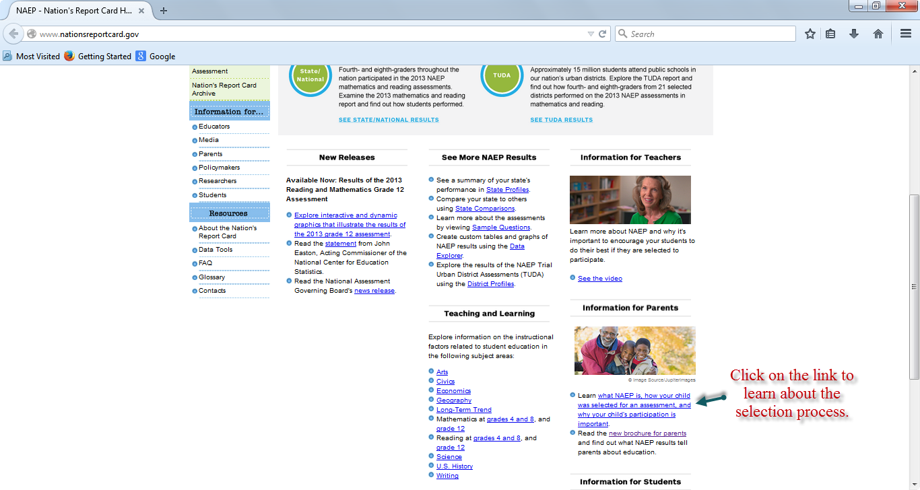

Sample Questions:
http://nces.ed.gov/nationsreportcard/itmrlsx/