In the Footsteps of the Great Composers

LUDLOWE MIDDLESCHOOL
From 9th to 17th of April 2015

DAY 1: USA – MADRID

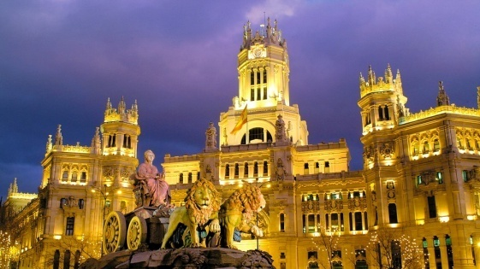
Arrival to Airport. Meeting the guide and transfer to the hotel 3 ***

Walking tour around the Hotel area.

Return to hotel for dinner and overnight stay.

DAY 2: MADRID

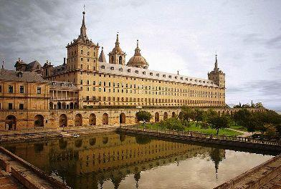

In the morning: Breakfast at the hotel. Departure

Walking tour through the old Madrid, Plaza del Sol, Palacio Real, Plaza de España, Gran Via, etc.

In the afternoon: guided tour of the “Museo del Prado”. Visit of the “Parque del Retiro” and free time.

Return to hotel for dinner and overnight stay.

DAY 3: MADRID – VALLE DE LOS CAIDOS - EL ESCORIAL – SEGOVIA - MADRID

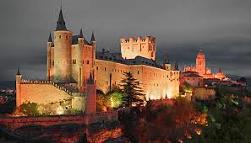
In the morning: Breakfast at the hotel.

9.00 departure to Valle de los Caidos and El Escorial. 10h00 meet local guide at Escorial. 10h30 Entrance to Monasterio del Escorial and then visit of Villa de San Lorenzo. 12h00 Valle de los Caidos, visit of the basilica.
14h00 Segovia, lunch at a local restaurant 16h30 meet a local guide next to Aqueduct. Walking guide visit of the centre of Segovia. Aqueduct, Casa de los Picos, Iglesia de San Martín, la Catedral. Visit Alcázar. Then back to Plaza Mayor and free time in the shopping area. In the evening return to Madrid with a stop at Mirador de Miraflores to see panoramic views of Segovia before the sunset.

Return to hotel for dinner and overnight stay.

(Excursion includes entrance to Cathedral/Alcazar, Valle de los Caidos and Monasterio del Escorial. Local guide visit to Monasterio del Escorial, San Lorenzo and Segovia)

DAY 4: MADRID

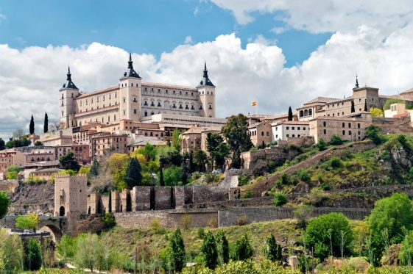
In the morning: Breakfast at the hotel.

In the morning activities related to the purpose of the trip.

In the afternoon visit to Teatro Real (www.teatro-real.com)

Return to hotel for dinner and overnight stay.

DAY 5: MADRID – TOLEDO – MADRID

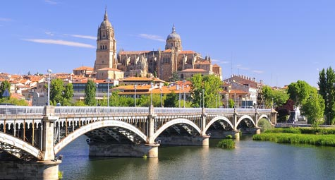
In the morning: Breakfast at the hotel.

9h00 departure to Toledo. 10h30 / 11h00 meet local guide at Puerta de la Bisagra. Guided visit and panoramic views at Los cigarrales de Toledo. Return to centre of Toledo. Guided visit of the interior of Cathedral. Visit to Greco painting at Iglesia de Santo Tomé then visit to Santa Maria la Blanca. Return to Plaza de Zocodover for free time to see street musician playing classic medieval instrument and some shopping. Lunch at a local restaurant. In the afternoon visit of either Alcazar or a sword factory.

Return to hotel for dinner and overnight stay.

(Excursion includes entrance to Cathedral/Santo Tome and Sta Maria la Blanca. Local guide)

DAY 6: MADRID

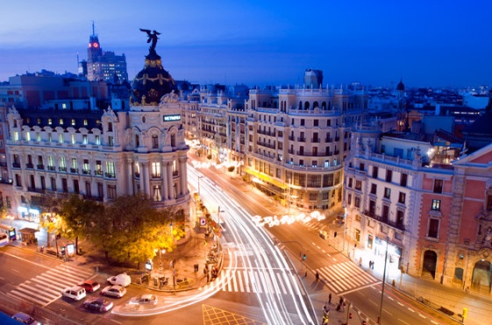
In the morning: Breakfast at the hotel.

In the morning activities related to the purpose of the trip.

In the evening attendance to concert at Auditorio Nacional de Música.

Return to hotel for dinner and overnight stay.

DAY 7: MADRID

In the morning: Breakfast at the hotel.

In the morning activities related to the purpose of the trip.

In the afternoon visit to Real Conservatorio Superior de Musica (www.rcsmm.eu/)

Return to hotel for dinner and overnight stay.

DAY 8: MADRID

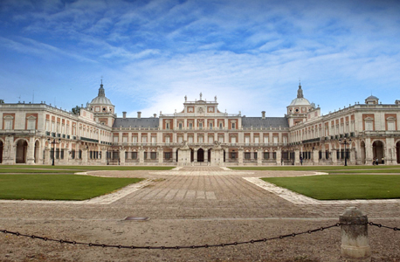
In the morning: Breakfast at the hotel.

In the morning activities related to the purpose of the trip.

In the afternoon free time.

Return to hotel for dinner and overnight stay.

DAY 9: MADRID – USA

In the morning: Breakfast at the hotel. Meeting with the suitcases and transfer to the airport. Departure from Madrid to USA.

PRECIO Y ELEMENTOS INCLUIDOS EN EL PROGRAMA
CARACTERÍSTICAS DEL PROGRAMA
Código del Programa | O-14-172 In the Footsteps of the Great Composers
Destino | SPAIN
Curso | Cultural Trip
Duración | 1 semana – 7 noches
Guide | English speaking guide who will accompany the group during all their stay and will be contactable 24h. The guide will help with introductions, animation during the visits of monuments and restaurants and organization of the arrival at the hotel.
Actividades y excursiones | As described above
Alojamiento | Double rooms for students and parents, single room for teachers
Régimen alojamiento | Full Board
Vuelos | JFK-MAD-JFK
Traslados | All transfers and excursions by private bus. All transfers within Madrid by public transport except for concert and/or rehearsal by private bus. Coach at disposal during excursions to Toledo and Segovia.
Seguros | Full insurance included
Acompañantes | Music Director is guest of the program
Extras | Spanish mobile  24h assitance
 | 20 to 25 PAX | 26 PAX or more
PRECIO VUELO* | $2.730 (Flight tax included) | $2.630 (Flight tax included)

FORMA DE PAGO
PAGOS | CANTIDAD | FECHA MÁXIMA
Primer pago | $750 | Before 6th December 2014
Segundo pago | $950 | Before 3th February 2015
Tercer pago* | $1030 | Before 3th March 2015
* Will depend on final number of participants

TITULAR: TRAVELENGLISH, SLNE
ENTIDAD: UNICAJA – OFICINA 0288
CC: ES52 2103 0288 00 0030002384

TRAVELENGLISH SLNE, CIAN: 296440-2. Inscrita en el Registro Mercantil de MALAGA, Tomo 4570 , Folio 203, Hoja 182, Inscripcion 1ª. C.I.F. : ESB93117901

