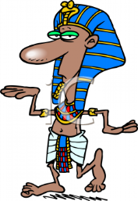
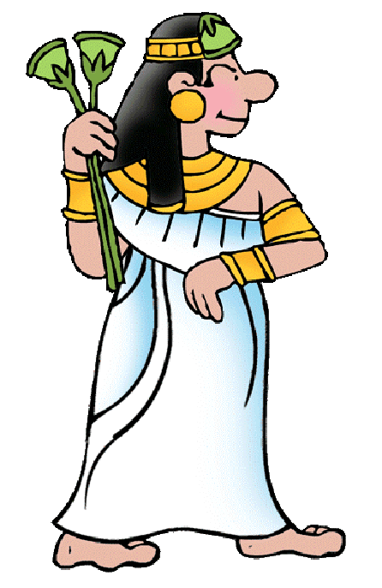
Name ______________________________________________ Period __________
Egypt Vocabulary
Lesson One:
- Delta
- Cataract
- Arid
- Predict
- Afterlife
Lesson Two:
- Diplomacy
- Nation-state
- Dynasty
- Vizier
- Hieroglyph
- Papyrus
- Pyramid
- Mummy
Lesson Three:
- Civil War
- Famine
- Cost-benefit analysis
Lesson Four:
- Pharaoh
- Reign
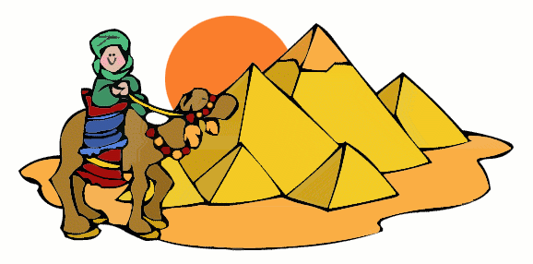
- Rural

