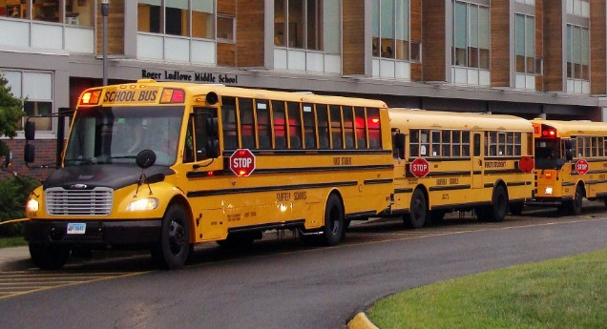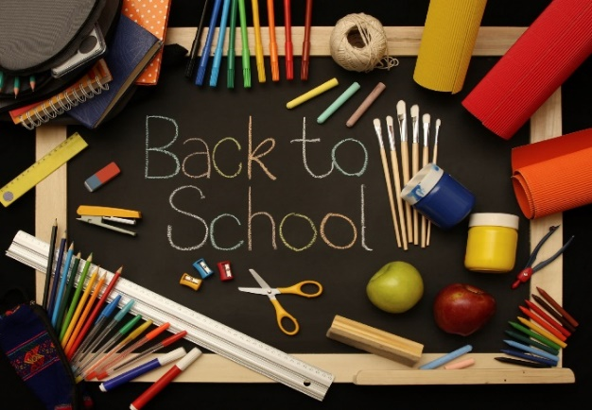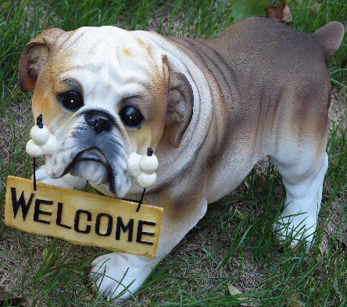

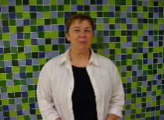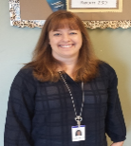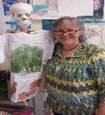

Mr. Moitoso –

Geography

**1st day of school**

**Thursday, August 29th**

**Open House**

**6th, 7th, and 8th grade Thursday Sept. 26th 6:30 p.m.**

**Parent Conferences**

**Thursday Oct. 10th**

**(afternoon)**

**Tuesday Oct. 15th**

**(evening)**

**Wednesday Oct. 16th (afternoon)**

***Dates to Remember***

* Earbuds/headphones
* 3 Ring Notebook
* 1 1/2“Binder (LA)
* 1 Subject Notebook (math)
* 3-4 Sturdy Pocket Folders
* Tab Dividers
* Pencils and Pens
* Pouch for Writing Implements
* Erasers
* Calculator
* Independent Reading Book
* Wide-rule loose-leaf paper

**RECOMMENDED SUPPLIES TO HAVE FOR YOUR FIRST DAY!**

In Science class, science goggles will be issued for grades 7 & 8 in September of their 7th grade year. If the goggles are lost or damaged they can be replaced for $5.00 by having the student see their respective science teacher with cash or a check made out to RLMS.

Hence**, we feel it is very important that each student have their own earbuds/headphones.**

In order for each child to have a successful year, parents/guardians, teachers and students need to work together. We would like you, the parents and guardians, to support our instruction, homework, and discipline efforts here at school. In return, we will update grade reports on Infinite Campus as one way to keep you informed about your child’s experiences in our crew. We are confident that with school and home working together, each and every student can have her or his most successful year yet.

Welcome to Crew 7L at Roger Ludlowe Middle School. We are looking forward to a terrific 7th grade experience for your child! We have planned curriculum crew days, as well as interdisciplinary units. All of these activities will focus on skills that are academically, socially, and developmentally appropriate for middle school students.

The teachers on crew 7L will be using Infinite Campus for a variety of functions. We recommend that parents and students familiarize themselves with the Infinite Campus format. The web address for this site is: <https://campus.fairfieldschools.org/campus/portal/fairfield.jsp>

If you do not have access to this site email: [reghelp@fairfieldschools.org](mailto:reghelp@fairfieldschools.org) for assistance.

This year 7th grade students should be receiving Chrome books sometime in the fall.

CREW 7L

Ms. Dias-Kohler –

Science

Mrs. Shemesh –

Math

Mrs. Natali – Language Arts

Mrs. Devito – Special Education

***Meet the 7L teachers!***