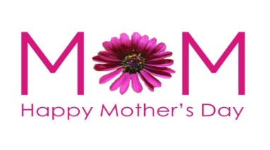
Dear Sherman Community Members,

It’s May and with only 32 days left in school year and we have lots to do! Our garden will be in bloom, field trips abound, assessment times are in place and the growth of a year’s instruction is evident in our students. Please check the PTA calendar for all of our events. There are too many to mention in this letter but I will alert you to a few of our most important events. On May 15th our annual Art Show will take place throughout the school. It is a well-attended event and a celebration of the arts. Mrs. Lynch and her committee have been hard at work all year in preparation for this event. Our final concert of the year will be held on May 20th in the APR. This is the fourth grade orchestra’s debut concert and the final show for our fifth grade class. We will also host book fair shopping on that evening as the book fair runs the week on May 18.
Special Person’s Day will be on Friday May 22 on the blacktop (weather permitting). This is our premiere event of the year and the unofficial lick off to Summer. Our school –wide field day is June 11th. K-2 classes will be enjoying outdoor events in the morning with grades 3-4 in the afternoon. Fifth grade will be joining in for some of the fun as well, but they are hosting their own field day on June 5th. We need volunteers so please contact your class parent liaison for more information. Our promotion ceremony will be held on Friday, June 12 at 4:30 in the afternoon. All are welcome. During these big events, please be cognizant of our neighbors when you park.

I have received notice of some outstanding bills from the food service department. If you received a letter, please pay the amount due. If not, I am responsible for the debt. Lunch will be offered up to the last day of school. Pizza is on the menu. If you have any library books in your home collection, please bring them in too before the end of the month. It does take some time to shelve all the books before summer vacation!

We hosted our Kindergarten Orientation on April 24th. So far we have 65 new students entering Kindergarten, a few students away from the 4 sections that we anticipate. I will keep you informed as the numbers change. We are excited to welcome the Sherman class of 2021!

Enjoy the beautiful Spring weather, finally! Outdoor recess if much anticipated this time of year. Please, no flip flops on the playground! Happy Mother’s Day to everyone!

Until next time….happy days!

Warmly,

Eileen

