# ROGER LUDLOWE MIDDLE SCHOOL

689 Unquowa Road

Fairfield, CT 06824-5001

Phone (203) 255-8345 – Fax (203) 255-8214

# Megan Tiley, Principal Ian Banner, Assistant Principal

Karin Shaughnessy, Assistant Principal Steven DeAngelo, Dean of Students

February 28, 2014

Dear Parents of Incoming Sixth Grade Students:

Welcome to Roger Ludlowe Middle School! We have already begun the transition from the elementary schools to the middle school. As you look around at some of the other fifth grade students in your child’s current class, you will undoubtedly recognize that middle school-aged students come in all shapes and sizes. In addition to their physical growth, young adolescents experience many changes—intellectually, socially, and emotionally—though they do not all grow at the same rate in any of these areas. Young adolescents seem almost grown-up one minute and then can behave like very young children the next minute. This developmental stage is vitally important as it is the transition between childhood and adolescence. At Roger Ludlowe Middle School, we recognize that the children between the ages of ten and fourteen benefit from educational experiences that match their years and we have built in opportunities for students to grow academically, socially and emotionally.

Middle school children often seek greater levels of independence by testing adult authority and supervision as they are becoming increasingly aware of themselves as individuals. However, with the guidance and support of their family and the school, these children can become more mature adolescents. In the upcoming three years, you’ll find that peer groups and friendships are very important to your child and the added peer pressures of this stage in life can bring on new challenges for you as parents. **Together we will help you and your child move through the next three years in a very positive and rewarding manner.**

Enclosed is a pamphlet that outlines our articulation program that is developed to help your child’s transition into Roger Ludlowe. We are now in the process of beginning to place your child in classes for next year. In the near future, you will be receiving more specific information about the process from your child's elementary school regarding articulation into sixth grade. In addition to language arts, math, social studies, science and Spanish, your child has the opportunity to take physical education twice a week and music three times a week. Each sixth grader who does not wish to take band, orchestra or chorus, must take general music. Music offerings are as follows:

* **Band** meets three times a week;
* **Orchestra** meets three times a week;
* **Chorus** meets three times a week;
* **Band and Chorus** in a combination of two times for band and one time for chorus;
* **Orchestra and Chorus** with orchestra meeting two times and chorus one time;
* **Music Technology** meeting two times followed by a study hall one time.

(Please refer to the insert for more specific descriptions of the music courses.)

Please discuss these music options with your child and make your music selection on the articulation card once you receive it. Please be aware that all music selections are for the full year. If your child will be receiving a special education service, the program will be finalized at the IEP meeting at the elementary level. A representative from the middle school will be at the IEP meeting to assist you.

Hopefully this brief information has been helpful. We have scheduled a parent orientation on **Thursday,** **March 27, 2014, at**

**7:00 p.m. in the Roger Ludlowe Middle School auditorium**. We hope to see you there.

Sincerely,

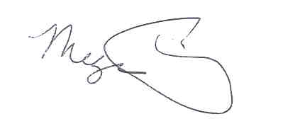 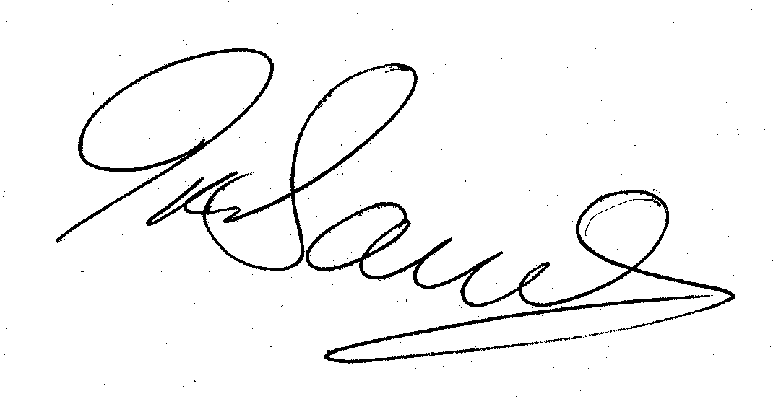 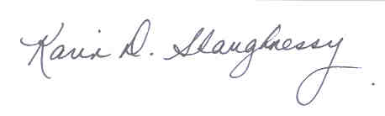

Megan Tiley Ian Banner Karin Shaughnessy

Principal Assistant Principal Assistant Principal