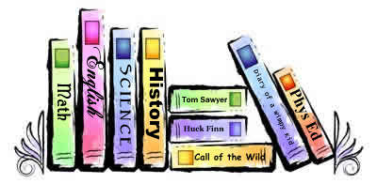
Fourth Grade Parent
Informational Meeting
Fifth Grade Departmentalization
May 28, 2015
6:00 PM*
Sherman Library
or
June 1, 2015
10:00 AM
Sherman APR
Come to hear how we will implement changing classes for math, reading, and science and social studies

All parents are welcomed

*(The Invention Convention will be held at 7:00 PM)

