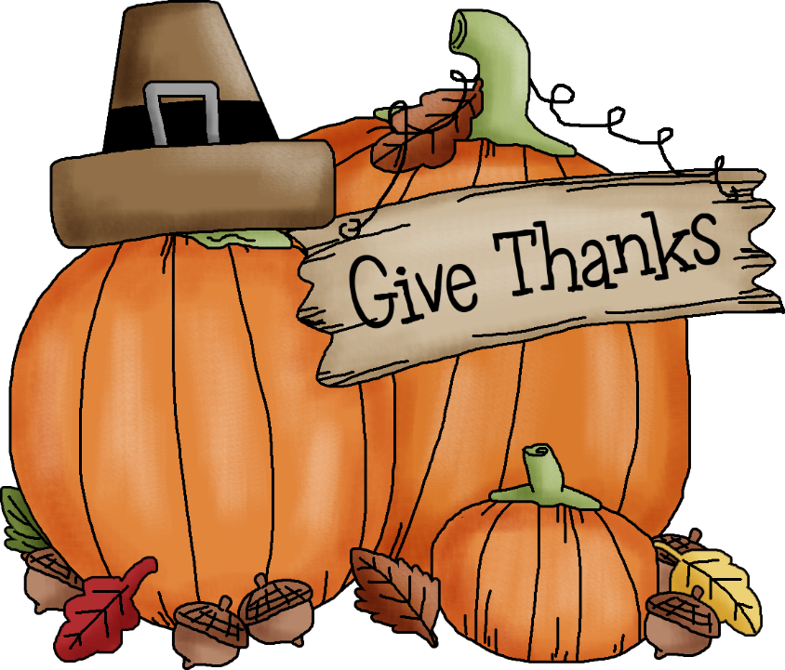
Dear Sherman Community Members,
November is here, conferences are over and now we settle into the time of year to give thanks for all our blessings and ready ourselves for the busy holiday season that is right around the corner. I wish you all a very happy Thanksgiving! While I am always thankful for my husband, children, grandchildren, brother, sisters, dad and cousins and friends I am also thankful for my school family, all of you make my world complete.
We have a few events to round out the month. Our next PTA meeting will be held on November 15th, 7:00 pm. Picture retake day is November 17th. We will also have a town meeting on that day where we will kick off our Looking for the Good project! Our Kindergarten share is on November 20th and our annual Turkey Trot will be held on November 22 which is an early dismissal day.
Thank you for supporting all of our fun events!
Enjoy the fall weather and time with your family and friends as we begin our end of year celebrations!

Until next time…..happy days!
Warmly,

Eileen

