and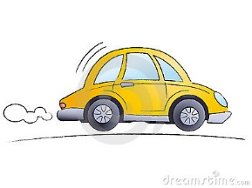
Let’s review stop, kiss, and go
- Enter from Beach Rd.
- Drive through the line
- drop your child off
- drive out, left only
Things NOT to do during stop, kiss, and go
Do not drop your child off while in line, all children
must exit to a sidewalk, safety first!
Do not try to park in the yellow NO PARKING zone!
Do not circumvent the line and drop off in the parking lot… very dangerous and slows things down for those that follow the rules!
Do not get out of your car at stop, kiss, and go!
Do not turn right until all buses have left school property!
So how do I make this better for everyone?
Please have your child ready to disembark when you pull up.
If you need assistance with your child, please park and we will help you.
Follow the rules; not only do you help everyone in line move quickly but you teach your child that rules are made to keep us safe and should be followed.
Thank You for following these rules

