# *ROGER LUDLOWE MIDDLE SCHOOL*

**689 Unquowa Road**

**Fairfield, CT 06824-5001**

**Phone (203) 255-8345 – Fax (203) 255-8214**

Meg Tiley, Principal Karin Shaughnessy, Assistant Principal

Ian Banner, Assistant Principal Steven DeAngelo, Dean of Students

April 21, 2014

Dear Parent(s)/Guardian(s),

Following out parent evening presentation a few weeks ago, our guidance counselor has and will continue to visit the feeder schools to meet with pertinent faculty to support as seamless a transition to middle school as possible. Yet, the pinnacle of the fifth grade transition process is always your child’s visit to Roger Ludlowe Middle School, along with all the students from our feeder schools. This year, this event will be held on **Wednesday, April 30, 2014**, and it will provide an opportunity for your child to view and participate in a wide variety of presentations and activities and to purchase lunch in the cafeteria. The cost of hot lunch, which will include pizza, salad, a veggie cup, bagels, fruit and milk, will be $2.75 per student. Additionally, other food choices may be available. However, if your child prefers, they can bring a bag lunch instead.

For this visit, we encourage incoming students to wear attire that reflects their respective elementary school colors, if possible. We also require that they wear sneakers for this day. Please note that the wearing of flip-flops will prevent students from participating in the PE activities. The entire day is designed for viewing the many varied courses at the middle school, and it will be a fantastic experience for all the students involved.

We are very excited for the opportunity to work with your child, and we look forward to working with you, too, both during and beyond this upcoming transition. If you have any questions, please do not hesitate to contact us.

Thank you so much.

Sincerely,

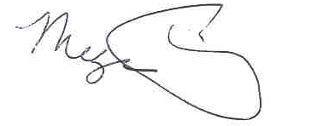 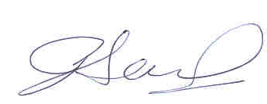 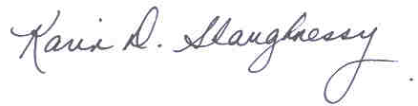

Megan Tiley Ian Banner Karin Shaughnessy

Principal Assistant Principal Assistant Principal