**Teacher News:**

* **Grade 3 Teachers are looking forward to meeting with parents this week and next for our Fall Conferences. It is a very informative time for us to share as well as learn more about your child.**
* **Recently, our students enjoyed a Tick Safety presentation by the Fairfield University Nursing Students. They combined some fun activities, games and a close up look at actual ticks. We should be safe and ready for our walk through Perry’s Mill Pond when we go on our River Lab study trip in early November!**
* **On Monday, Oct 17, our students enjoyed the Fairfield Fire Department’s home safety presentation in each of our classes. Fire safety tips were shared as students located “unsafe” situations in the Life Safety Trailer which was parked in our parking lot. Be sure to review a plan for safety in your home with your child. Where are the smoke detectors? In the event of a fire, what should you do to get out of the various rooms in the house? Where is your family’s “meeting place”?**
* **Please note your class Mill River trip date below. Remember to have your child dress for being outside. Layers are best, but please check the weather. Please have your child wear long pants, socks and comfortable shoes. Permission slips will be coming home soon.**
* **Our Halloween celebration will be Mon. 10/31. Students should BRING their costume to change into later in the day. The parade will be at 2:30 and all parents and families are welcome OUTSIDE as our school parades around the building. Thank you in advance to our room parents who will manage our Halloween party/activities for the students in the classroom following the parade.**

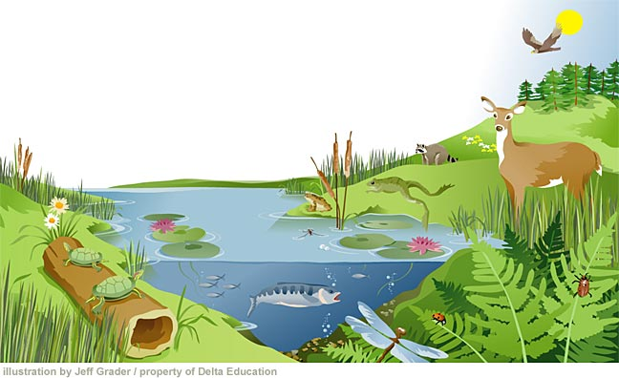

**Important Dates:**

**Early Dismissal Conferences:**

**10/20, 10/26, 10/27**

**3H and 3I Mill River Study Trip 11/1**

**3S and 3M Mill River Study Trip 11/2**

**Science/Social Studies: As we prepare for our River Lab study trip, students are learning how the parts of a river basin system work together to manage all the water. We are enjoying several inquiry lessons in class as we work with basin models and stream trays to observe the work of the water. Further study includes the river habitats, food chains and animal adaptations. All of our learning comes together during our Nov. trip as we build a model river and observe the habitats. Thank you to our parent guides!!**

**Math Students are currently working in our new Bridges Math Unit 2- Early Multiplication. Students are learning to use a variety of strategies from skip counting, repeated addition, equal groups, ratio tables and number lines to learn multiplication concepts and solve problems with increasing efficiency. Students should be practicing multiplication facts for 2, 5, and 10 facts at this point! Goals for addition facts=17 and subtraction facts=16 for our one minute timings.**

**Reading/Language Arts:**

**Our “Reading is Thinking” comprehension unit is well under way! Students are immersed in independent and small group reading with a “wide awake” mind as they “stop and jot” at thoughtful parts of the text to think about something surprising, interesting, confusing, or simply the author’s use of language. Last week we focused on visualizing the author’s words in story critical areas such as the setting, character, and plot. This week we will be focusing on making connections between the text to ourselves, other texts, and the world around us.**

**In writing, we are immersed in our Narrative unit. Throughout the unit, children have been setting goals to help improve their writing. Be sure to ask your child about the Gr. 3 narrative checklist and what goals they have been focusing on through the unit. Goal rings and checklists have been helpful to keep us on track. At the end of this unit students will be assessed with a 45 minute On Demand post assessment before moving on to our Informational Writing unit.**