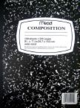
*Please remember that we have classroom supplies for all students to share. If you would prefer your child has his or her own, or are concerned about germs and sharing, please supply your child with their own materials (clearly labeled with their name).
- Bookbag/Backpack
- Hard plastic pencil case
- 5 #2 pencils
- One highlighter
- Eraser
- Colored pen for correcting
- 2 Black and white composition notebooks (Reader’s and Writer’s)
- 1 One subject spiral notebook (Math)
- Crayons
- 5 two pocket colored folders in the following colors: Red for Reading, Orange for Writing, Yellow for Math, Green for Science, and Blue for Social Studies. If you would like you can write the subject and your name on each.
- If you prefer your child to use their own earbuds rather than the school provided headphones, you can send in a set to keep at school. These earbuds should be sent in a ziplock bag with your child’s full name and class on the front. All computers still have headphones that your child can use if you prefer not to send in earbuds, as this is optional.
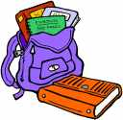
- A smile and a positive attitude

