Eye Illusions (Ambiguity Pictures)

Beautiful scene. But there is something more to it.

Who do you like more - women or saxophone players?

Are there really just flowers?

You may read across and upright.
A-B-C or 12-13-14?

Color Blindness Tests
1st Color Blindness Test - can you see a "12" on this plate?
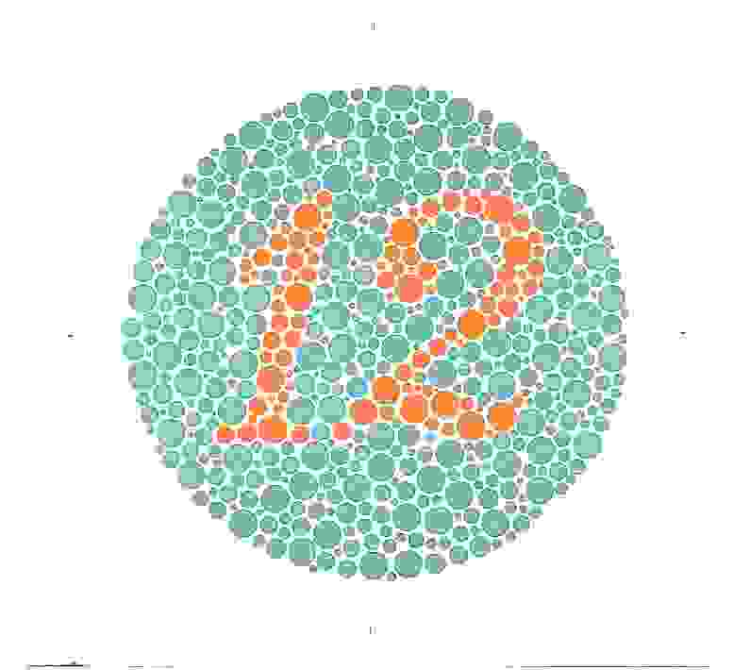

2nd Color Blindness Test - there is a "26" on this plate.
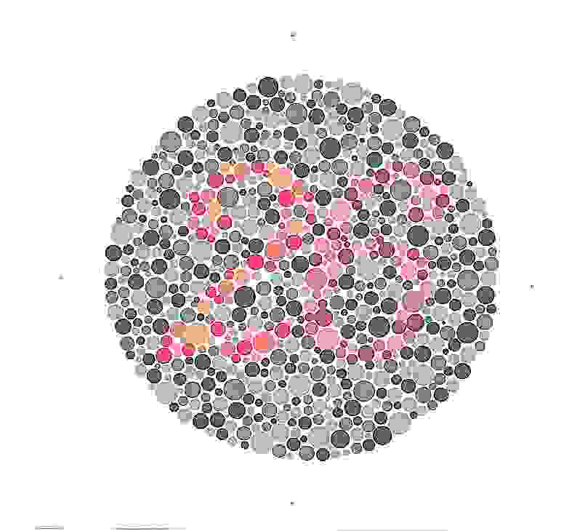

3rd Color Blindness Test - can you trace a line from one "X" to the other?
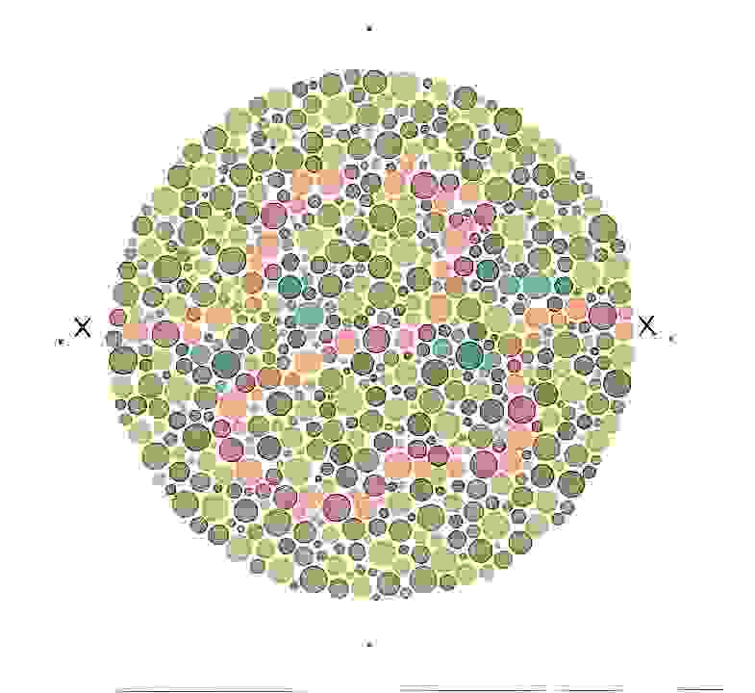

4th Color Blindness Test - you should see 58 (upper left), 18 (upper right), E (lower left) and 17 (lower right).
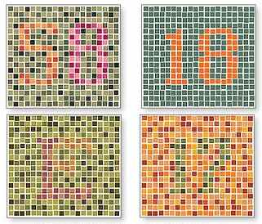

Moving Objects Illusions
There is only illusory motion in the following static image due to color contrasts and shape position. (© Akiyoshi Kitaoka: Used with permission.)

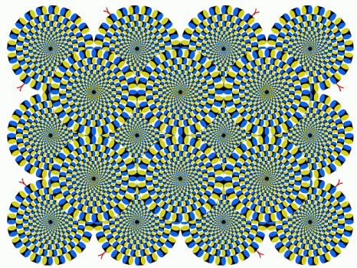

Another static picture. (© Akiyoshi Kitaoka: Used with permission.)

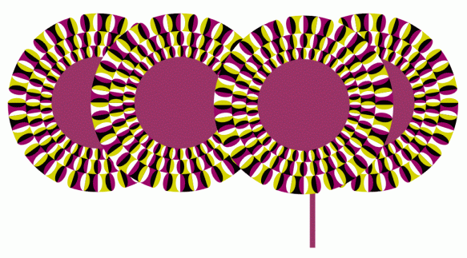

Motion is just an eye illusion. (© Akiyoshi Kitaoka: Used with permission.)

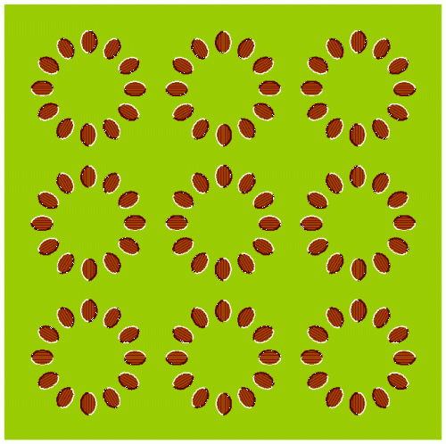

There is nothing moving below. (© Akiyoshi Kitaoka: Used with permission.)

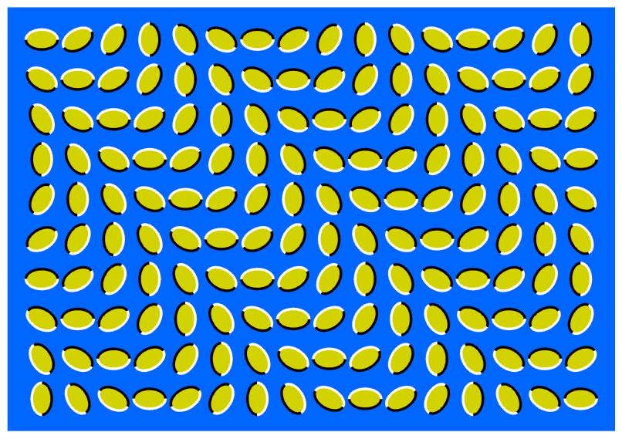

A wonderful moving bicycle illusion. (© Akiyoshi Kitaoka: Used with permission.)

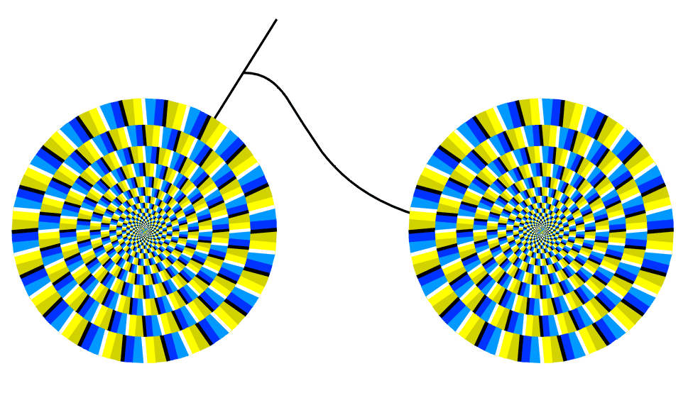

A hilarious moving curtain illusion. (© Akiyoshi Kitaoka: Used with permission.)

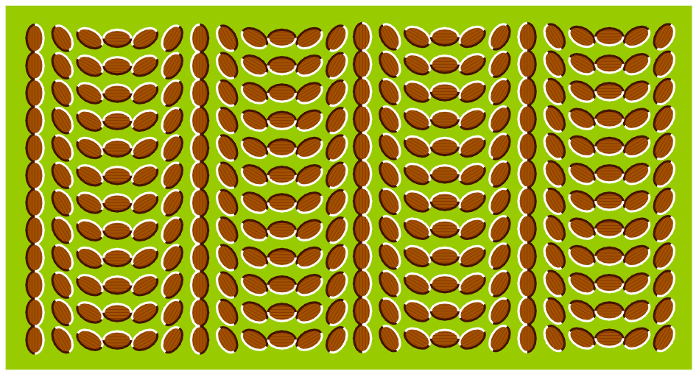

Moving circles. (© Akiyoshi Kitaoka: Used with permission.)

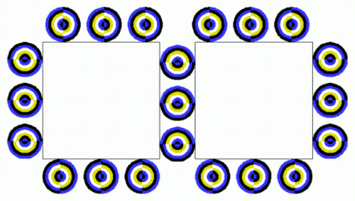

Boats on the picture are not moving. It's just an eye illusion. (© Akiyoshi Kitaoka: Used with permission.)

Stare at the dot in the center of the circle and then move your head closer to it. Neat!

Impossible Objects Illusions
Our brain tries to do its best usually, however, there are instances when it fails to process correctly what the eye sees. The brain makes sense of shapes and symbols. It's trying to put them together like a jigsaw puzzle, formulating that which isn't there to that which is believable. 2D figure is subconscionsly interpreted as 3D object although such object can not exist.
The Penrose Triangle, also known as the tribar is one of the most well-known Impossible Figures. Try to trace a line in the triangle and you would have to trace it three times around the triangle before coming back to where you started. (by Roger Penrose)
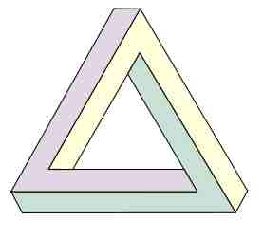

The Penrose stairs is a variation on the Penrose triangle. You could climb the stairs forever and never get any higher. That is only possible in two dimensions. This endless staicase can be found also in the paintings of M. C. Escher or also in the movie Inception by Christopher Nolan. (by Roger Penrose)
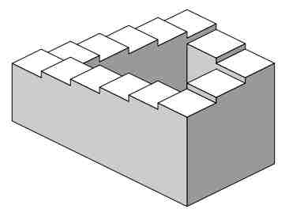

This impossible object (blivet) is called "Devil's Fork" or "Three-Pronged Poiuyt" or "Schuster's Conundrum" (by D. H. Schuster)

This is one of classic optical illusions - it is called dancing elephant. Try to count the number of his legs (by Roger Shepard).
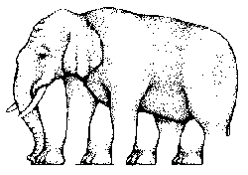

Given the wood do you think you could make this
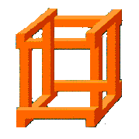

Another impossible figure.

A realistic photo or just another undecidable figure?
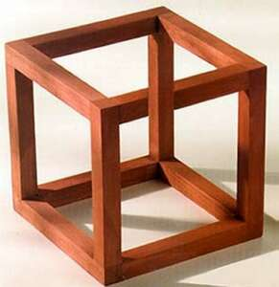

Try to arrange dice like this.
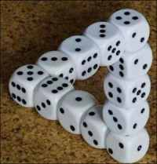

Another interesting building.
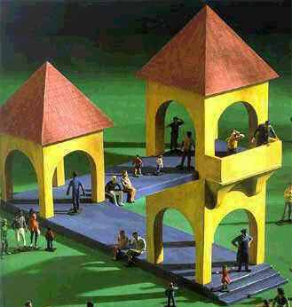

This corner house is a bit tricky. Question: Is the corner concave or convex? Use your palm to cover the upper half of the picture and the corner will be bulged out. However, if you cover the lower half, then it will seem as the inner corner. Amazing.
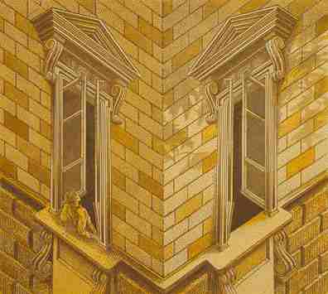

Word Illusions
If you can read the following picture, then you can shout ...
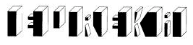

Can you read the below?
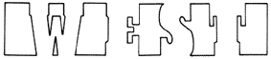

At first glance, what do you see? Could it be the word "liar" or is it something more. I would definitely give this one a second look!
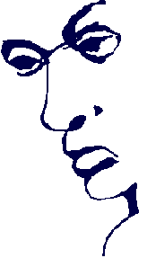

This painting is called "Optical Illusion" - literally - you can read it (by John Langdon).

Victory or defeat? Both (by Veja Magazine).

Have you ever noticed a hidden arrow in the FedEx logo? It stands for speed and precision. Check the space between "E" and "x".

