Unit 14
The Nervous Systems
Chapter 4

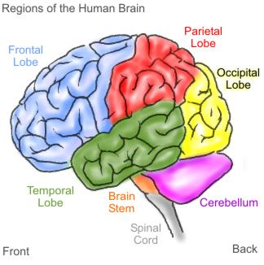

Chap. 4 Sect. 1: The Nervous System
Chap. 4 Sect. 2: Responding to the Environment

Name _____________________________________________ Period_____

Nervous System Syllabus:

Vocabulary:
Chapter 4 Section 1:
Central Nervous System
Peripheral Nervous System
Neuron
Nerve
Brain
Chapter 4 Section 3:
Integumentary System
Reflex
Feedback Mechanism
Retina
Cochlea

Readings:

Chapter 4 Section 1: Pages 80-86
Chapter 4 Section 2: Pages 88-93

Assignments:

At home expectations:
- Learn vocabulary and definitions.
- Make 2-column notes or flashcards for the vocabulary words.
- Read and complete the Section Review Answer Sheet pages for Sect 1 and 2 readings.
- Study for Chapter Test by using a method of your choosing.

Class work:
- Video Notes
- Class Notes
- The Stroop Effect Experiment
- Coloring pages
5. Unit Test.

Expected Completion Date:

Unit Vocabulary Definitions
Extra Credit: 5 points
Complete all 4 steps of the Quick Lab “Where’s the Dot?” on pg. 91.

Chapter 4 Section 1:

Central Nervous System – (CNS) the brain and spinal cord

Peripheral Nervous System – (PNS) all the parts of the nervous system except for the brain and the spinal cord

Neuron – a nerve cell that us specialized to receive and conduct electrical impulses

Nerve – a collection of nerve fibers (axons) through which impulses travel between the central nervous system and other parts of the body

Brain – a mass of nerve tissue that is the main control center of the nervous system

Chapter 4 Section 2:

Integumentary System- the organ system that forms a protective covering on the outside of the body

Reflex – an involuntary and almost immediate movement in response to a stimulus

Feedback Mechanism – a cycle of events in which information from one step controls or affects a previous step

Retina – a layer of light sensitive cells in the eye that receives images and transmits them through the optic nerve to the brain

Cochlea – a coiled tube that is found in the inner ear and that is essential to hearing

Video Notes
Human Body for Students: Nervous System

http://player.discoveryeducation.com/index.cfm?guidAssetId=C34883CD-F012-4CBE-8CC8-132295D441FC&blnFromSearch=1&productcode=US

- What are the two central parts of the nervous system?

- What carries messages to the cell body?

- What carries messages away from the cell body?

- What is the name of the gap that impulses must cross over?

- What are the two main division of the nervous system?

- Which part of your brain controls thinking?

- Which part of the brain connects the brain with the spinal cord?

- Which part of the brain controls voluntary actions?

- A B C D E.

- Complete the number sequence… 5, 8, 11,________, ________, _________.

- List the things this shape could be…

- What are the five senses?

Class Notes for the Nervous System - Section 1
Two Systems Within a System
Peripheral Nervous System: ________________________________________________________________________________________________________________________________________________
Neuron Structure:
________________________________________________________________________Information Collection: ________________________________________________________________________Delivering Orders: _______________________________________________________________
Nerves:
______________________________________________________________________________________________________________________________________________________________________________________________________________
Somatic and Autonomic Nervous System: ________________________________________________________________________________________________________________________________________________________________________________________________________________________
Central Nervous System:
________________________________________________________________________________________________________________________________________________

The Cerebrum
________________________________________________________________________ ________________________________________________________________________

The Cerebellum
________________________________________________________________________ ________________________________________________________________________

The Medulla
________________________________________________________________________ ________________________________________________________________________

The Spinal Cord
________________________________________________________________________________________________________________________________________________
Class Notes for Responding to the Environment - Section 2

Sense of Touch ________________________________________________________________________________________________________________________________________________________________________________________________________________________________________________________________________________________________

Responding to Sensory Messages ________________________________________________________________________________________________________________________________________________________________________________________________________________________________________________________________________________________________

Sense of Sight ________________________________________________________________________________________________________________________________________________________________________________________________________________________________________________________________________________________________

Sense of Hearing ________________________________________________________________________________________________________________________________________________________________________________________________________________________________________________________________________________________________

Sense of Smell ________________________________________________________________________________________________________________________________________________________________________________________________________________________________________________________________________________________________

The Neuron

Color and label the nucleus, cell body, dendrite, axon, and axon terminal (use book pg.81)
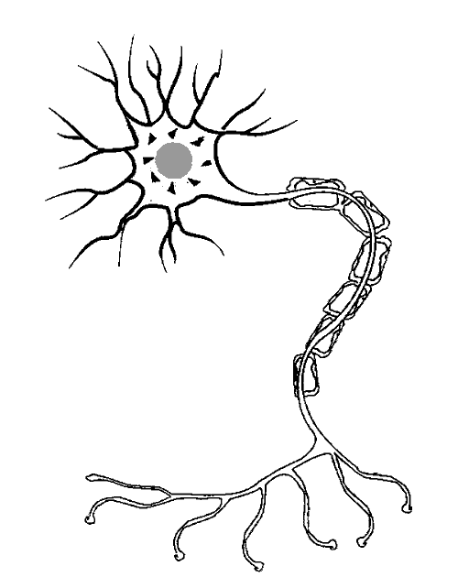
In your own words, describe the function of the neuron in the space below:
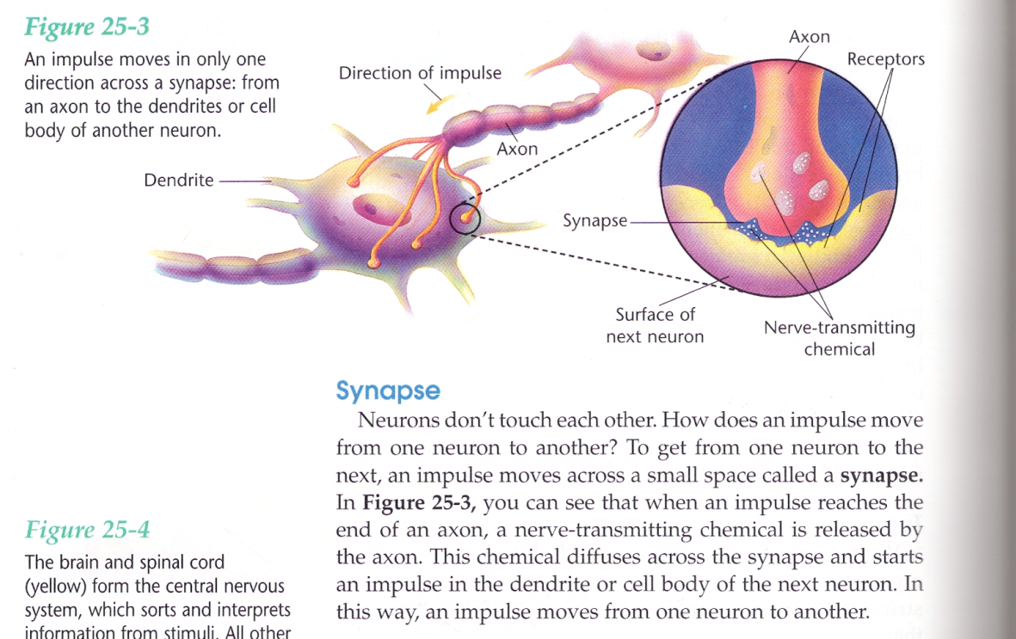

The Synapse

Color and label the diagram below using the information from above.
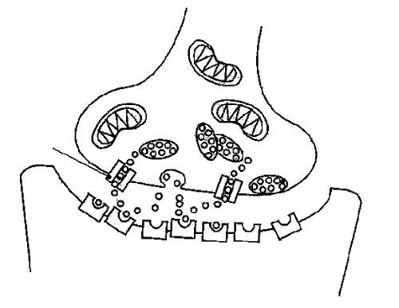
In your own words, describe the function of the synapse in the space below:
The Brain - top view
Label the hemispheres of the brain and list activities that each hemisphere controls (use book pg. 84)

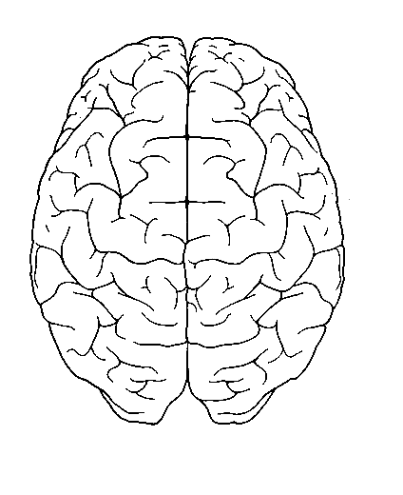

The Stroop Effect Experiment
To make the test difficult, use markers, pens, pens or crayons and color in the words with colors that are different from what the word says. For example, color the word "BLUE" with red.

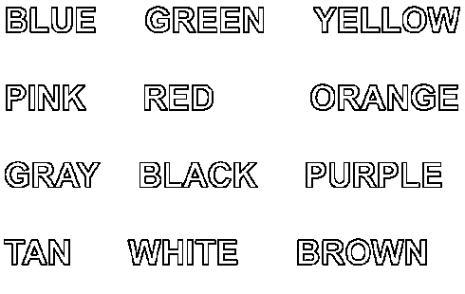
Questions:
How do words influence what we see?
How does the brain handle "mixed messages"?
Estimated Time: 30 minutes
Procedure and Materials
- First, choose one of the above questions to address and make a prediction/hypothesis based on what you currently know about "mixed messages".
- Second, attempt the activity using the above color chart five separate times. Using the data chart (on the following page), keep track where you mix up the words and colors or have trouble reading the colors.
- Next, analyze your data by answering the following questions or make up one to four of your own questions. Which words tend to trip you up? Was it the same word every time? Did the color of the word make a difference? Did it get easier or harder each time?
- Finally, write a statement of conclusion that is based on the analysis of your data. This is where you will attempt to answer the original question and discuss your prediction.
Prediction
________________________________________________________________________
________________________________________________________________________
________________________________________________________________________
________________________________________________________________________
________________________________________________________________________
________________________________________________________________________

Data Table
Write in 4 questions or observations you will be looking for during the activity. (from step 3 on previous page) | Question 1 | Question 2 | Question 3 | Question 4
Trial Number  1 | Observation 1: | Observation 2: | Observation 3: | Observation 4:
2 | Observation 1: | Observation 2: | Observation 3: | Observation 4:
3 | Observation 1: | Observation 2: | Observation 3: | Observation 4:
4 | Observation 1: | Observation 2: | Observation 3: | Observation 4:
5 | Observation 1: | Observation 2: | Observation 3: | Observation 4:
Analysis
________________________________________________________________
________________________________________________________________
________________________________________________________________
________________________________________________________________
________________________________________________________________
Statement of Conclusion
________________________________________________________________________
________________________________________________________________________
________________________________________________________________________
________________________________________________________________________
________________________________________________________________________
________________________________________________________________________
________________________________________________________________________
________________________________________________________________________
The Brain
Read the definitions below, then label the brain anatomy diagram. Color in each section a different color.
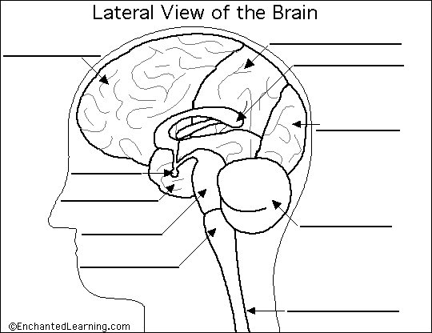
Cerebellum - the part of the brain below the back of the cerebrum. It regulates balance, posture, movement, and muscle coordination.  Corpus Callosum - a large bundle of nerve fibers that connect the left and right cerebral hemispheres. In the lateral section, it looks a bit like a "C" on its side.  Frontal Lobe of the Cerebrum - the top, front regions of each of the cerebral hemispheres. They are used for reasoning, emotions, judgment, and voluntary movement.  Medulla Oblongata - the lowest section of the brainstem (at the top end of the spinal cord); it controls automatic functions including heartbeat, breathing, etc.  Occipital Lobe of the Cerebrum - the region at the back of each cerebral hemisphere that contains the centers of vision and reading ability (located at the back of the head). | Parietal Lobe of the Cerebrum - the middle lobe of each cerebral hemisphere between the frontal and occipital lobes; it contains important sensory centers (located at the upper rear of the head).  Pituitary Gland - a gland attached to the base of the brain (located between the Pons and the Corpus Callosum) that secretes hormones.  Pons - the part of the brainstem that joins the hemispheres of the cerebellum and connects the cerebrum with the cerebellum. It is located just above the Medulla Oblongata.  Spinal Cord - a thick bundle of nerve fibers that runs from the base of the brain to the hip area, running through the spine (vertebrae).  Temporal Lobe of the Cerebrum - the region at the lower side of each cerebral hemisphere; contains centers of hearing and memory (located at the sides of the head).
http://www.nytimes.com/2013/04/11/science/brains-as-clear-as-jell-o-for-scientists-to-explore.html?_r=0
April 10, 2013

Brains as Clear as Jell-O for Scientists to Explore

By JAMES GORMAN
The visible brain has arrived — the consistency of Jell-O, as transparent and colorful as a child’s model, but vastly more useful. Scientists at Stanford University reported on Wednesday that they have made a whole mouse brain, and part of a human brain, transparent so that networks of neurons that receive and send information can be highlighted in stunning color and viewed in all their three-dimensional complexity without slicing up the organ.
Even more important, experts say, is that unlike earlier methods for making the tissue of brains and other organs transparent, the new process, called Clarity by its inventors, preserves the biochemistry of the brain so well that researchers can test it over and over again with chemicals that highlight specific structures and provide clues to past activity. The researchers say this process may help uncover the physical underpinnings of devastating mental disorders like schizophrenia, post-traumatic stress disorder and others.
The work, reported on Wednesday in the journal Nature, is not part of the Obama administration’s recently announced initiative to probe the secrets of the brain, although the senior author on the paper, Dr. Karl Deisseroth at Stanford, was one of those involved in creating the initiative and is involved in planning its future.
Dr. Thomas Insel, director of the National Institute of Mental Health, which provided some of the financing for the research, described the new work as helping to build an anatomical “foundation” for the Obama initiative, which is meant to look at activity in the brain.
Dr. Insel added that the technique works in a human brain that has been in formalin, a preservative, for years, which means that long-saved human brains may be studied. “Frankly,” he said, “that is spectacular.”
Kwanghun Chung, the primary author on the paper, and Dr. Deisseroth worked with a team at Stanford for years to get the technique right. Dr. Deisseroth, known for developing another powerful technique, called optogenetics, that allows the use of light to switch specific brain activity on and off, said Clarity could have a broader impact than optogenetics. “It’s really one of the most exciting things we’ve done,” he said, with potential applications in neuroscience and beyond.
“I think it’s great,” said Dr. Clay Reid, a senior investigator at the Allen Institute for Brain Science in Seattle, who was not involved in the work. “One of the very difficult challenges has been making the brain, which is opaque, clear enough so that you can see deep into it.” This technique, he said, makes brains “extremely clear” and preserves most of the brain chemistry. “It has it all,” he said.
In the mid-2000s, a team led by Dr. Jeff Lichtman at Harvard developed a process called Brainbow to breed mice that are genetically altered to make their brain neurons fluoresce in many different colors. The new technique would allow whole brains of those mice with their rainbow neurons to be preserved and studied.
“I’m quite excited to try this,” Dr. Lichtman said. There are several ways to make tissue transparent. The key to the new technique is a substance called a hydrogel, a material that is mostly water held together by larger molecules to give it some solidity.
Dr. Chung said the hydrogel forms a kind of mesh that permeates the brain and connects to most of the molecules, but not to the lipids, which include fats and some other substances. The brain is then put in a soapy solution and an electric current is applied, which drives the solution through the brain, washing out the lipids. Once they are out, the brain is transparent, and its biochemistry is intact, so it may be infused with chemicals, like antibody molecules that also have a dye attached, that show fine details of its structure and previous activity.
Techniques like this, said Dr. Insel, “should give us a much more precise picture of what is happening in the brains of people who have schizophrenia, autism, post-traumatic stress disorder, bipolar disorder and depression.”
The tricky part was getting the right combination of temperature, electricity and solution. And it was very tricky indeed, said Dr. Chung. Over the course of years spent trying to make it work, he said, “I burned and melted more than a hundred brains.”
But with the paper’s publication, the recipe is now available to anyone who wants to use it, and, he said, “I think it will be relatively easy.”
The technique has its limits, of course. Dr. Chung said more work needed to be done before it could be applied to a whole human brain, because a human’s brain is so much larger than a mouse’s, and has more lipids.
Dr. Chung said he planned to start his own lab soon and to work on refining the technology. But he pointed out that it is already known that it works on all tissue, not just brains, and can be used to look for structures other than nerve cells. On his laboratory bench, he said, “I have a transparent liver, lungs and heart.”
Dr. Reid agreed that Clarity had applications in many fields. “It could permeate biology,” he said.
For the reading:
- List all the words you don’t know and define them (1 per line!):
______________________________________________________________________
______________________________________________________________________
_______________________________________________________________________
_____________________________________________________________________________________________________________________________________________
______________________________________________________________________
_______________________________________________________________________
_______________________________________________________________________ ______________________________________________________________________
______________________________________________________________________
_______________________________________________________________________
_______________________________________________________________________ ______________________________________________________________________
______________________________________________________________________
_______________________________________________________________________
_______________________________________________________________________ ______________________________________________________________________
______________________________________________________________________
_______________________________________________________________________
_______________________________________________________________________
2. What did you find out or learn from the reading – Cite text evidence!! ______________________________________________________________________
______________________________________________________________________
_______________________________________________________________________
_______________________________________________________________________ ______________________________________________________________________
______________________________________________________________________
______________________________________________________________________
_______________________________________________________________________
_______________________________________________________________________ ______________________________________________________________________
_______________________________________________________________________
_______________________________________________________________________ _______________________________________________________________________

3. Would you recommend this article to a classmate? Why or why not?
______________________________________________________________________
______________________________________________________________________
_______________________________________________________________________
_______________________________________________________________________ ______________________________________________________________________
______________________________________________________________________
_______________________________________________________________________
_______________________________________________________________________ _______________________________________________________________________
_______________________________________________________________________
Section Review
Section 1 The Nervous System, pg. 87 in textbook
Answer Sheet:
1.______________________________________________________________________________________________________________________________________________

2.______________________________________________________________________________________________________________________________________________

3. ___________________

4.__________________________________________________________________________________________________________________________________________________________________________________________________________________________________________________________________________________________________________________________________________________

5.______________________________________________________________________________________________________________________________________________________________________________________________________________________

6.______________________________________________________________________________________________________________________________________________________________________________________________________________________

7.______________________________________________________________________________________________________________________________________________________________________________________________________________________________________________________________________________________________

8.______________________________________________________________________________________________________________________________________________________________________________________________________________________

9.______________________________________________________________________________________________________________________________________________

10.____________________________________________________________________________________________________________________________________________
Section Review
Section 2 Responding to the Environment, pg. 93 in textbook
Answer Sheet:
1.______________________________________________________________________________________________________________________________________________

2.______________________________________________________________________________________________________________________________________________

3. ___________________

4.______________________________________________________________________________________________________________________________________________________________________________________________________________________________________________________________________________________________

5.______________________________________________________________________________________________________________________________________________________________________________________________________________________

6.______________________________________________________________________________________________________________________________________________________________________________________________________________________

7.______________________________________________________________________________________________________________________________________________________________________________________________________________________________________________________________________________________________

8.______________________________________________________________________________________________________________________________________________________________________________________________________________________
Omit #9

10_____________________________________________________________________________________________________________________________________________

11.____________________________________________________________________________________________________________________________________________
Study Guide – Know this for the test!
1. The spinal cord is protected by _______________________.

2. Papillae are ________________________________________________ .
3. Receptors in your skin include _____________________________________ ______________________________________________________________

4. A feedback mechanism is _________________________________________________________ ___________________________________________________________________________________________________________________________

5. Olfactory cells are ______________________________________________________________ ______________________________________________________________

6. What enables you to smell? _______________________________________________________

7. In a neuron, impulses move from_________________ to__________________.

8. Which are the functions of the medulla? ______________________________________________________________ ______________________________________________________________
9. What is the function of the cerebrum? _______________________________________________

10. What carries information between the body and the central nervous system? ______________________________________________________________
11. What body system does skin belong to? _____________________________________________

12. In which order are neurons activated during a reflex response to a painful stimulus? ____________________________________________________________________________________________________________________________
13. Which body functions are controlled by the autonomic nervous system? ____________________________________________________________________________________________________________________________

14. What is the region of the brain that controls heart rate? _______________________________________

15. What is the nerve cell specialized for transferring messages? ___________________________________

16. Sympathetic and parasympathetic systems work together to maintain this: _________________________

17. What is the specialized nerve ending that detects changes inside and outside the body? _______________

18. The part of a neuron that carries impulses away from the cell body is: ____________________________

19. The part of the nervous system that includes the brain and spinal cord is: __________________________

20. The brain region that helps maintain balance is _________________________________

21. Which system includes the spinal cord and brain? ________________________________

22. Which system controls body functions not under conscious control (you don’t think about)?

23. Which neuron carries nerve impulses to muscles or glands?

24. Which system connects the central nervous system, or CNS, to the rest of the body?

25. Which neuron gathers information from inside or outside the body?

26. Which system sends messages to muscles under voluntary control?

