Mrs. West Science in the computer lab
Complete the questions on the first page and on the bottom of page 3, and have FUN exploring the rest.

Questions | Site to Use | Answer
What is photosynthesis?  Why does the plant need glucose (food)? | photosynthesis  http://www.eschooltoday.com/photosynthesis/what-is-photosynthesis.html
What organelle turns glucose into ATP?  How are humans and plants connected? | Cellular Respiration Simple story  http://www.youtube.com/watch?v=eo5XndJaz-Y
How do cells get the oxygen they need to perform cellular respiration?  Take the quiz and print to turn in. | http://www.brainpop.com/science/cellularlifeandgenetics/passivetransport/
- Are breathing and respiration the same thing?  - What does oxygen help us do?  - What do we exhale?  - Do plants perform cellular respiration?  - What process do cells use if there is not enough oxygen?  - Take the quiz, print and turn in. | http://www.brainpop.com/science/cellularlifeandgenetics/cellularrespiration/  TomlinsonMS  Awesome
Why are plants green? | why plants are green?  https://www.youtube.com/watch?v=aAQYpra4aUs
Genes  What do genes make? | What is a gene  https://www.youtube.com/watch?v=5MQdXjRPHmQ | Just for fun
DNA transcription & Translation | How we make proteins  https://www.youtube.com/watch?v=41_Ne5mS2ls&list=RDyrQzEw9xY5k&index=27 | This is just really cool to watch
Viruses  Cool animation of how viruses work.  Just watch | Flu virus - how it works  https://www.youtube.com/watch?v=Rpj0emEGShQ | Also cool to watch
How cell protect you. We watched this in class. | Cells and viruses  https://www.youtube.com/watch?v=oqGuJhOeMek | Organelle review – just incase you forgot
The different types of cells in a multicellular organisms. | 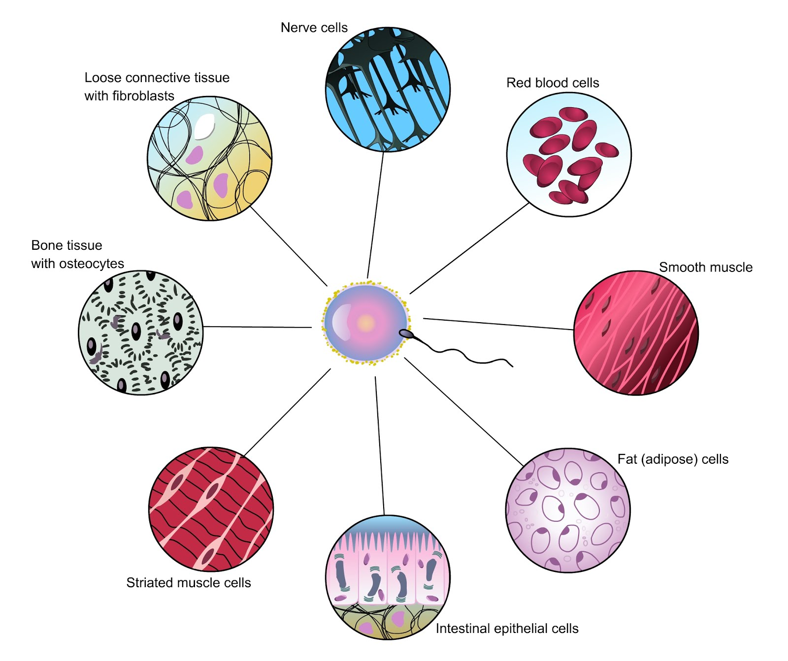 | Bone, epithelial, adipose, muscle, cartilage, nerve, blood.
Explore this website to find an experiment for your extra credit. | http://www.nclark.net/Cells | Experiment ideas
Science | Radio | KSED 101.9
photosynthesis song  lyrics attached | photosynthesis | Simple  H₂O+CO₂=C₆H₁₂O₆ +6O₂
Cellular Respiration | Cellular Respiration  http://www.youtube.com/watch?v=FHWbjnzfi_U | Simple
Photosynthesis song 123 | https://www.youtube.com/watch?v=yrQzEw9xY5k | Gets a little more complicated
Cell theory | All living this are composed of CELLS | Know your scientists
Cell City | http://www.youtube.com/watch?v=u4ki28XLzOA

List 2 things you learned today.

1. _______________________________________________________________________

2. ________________________________________________________________________

What would you like to know more about? ________________________________________

__________________________________________________________________________

What was your favorite part of this lesson?

__________________________________________________________________________

__________________________________________________________________________

What is your favorite science website?

__________________________________________________________________________

Lyrics for the Photosynthesis Song

Plant all around us

Plants are special yes
Please remember this
They do a special job that we all love it’s photosynthesis

Sunlight + CO₂ + H₂O creates C₆ H₁₂ O_{6 (sugar)} +O₂

Photosynthesis is for the green plants you should know
Absorbing sun energy helps them stay strong and grow
Cause photosynthesis, plants take in CO₂
The carbon dioxide is in the air and that’s what plants remove.
Hey photosynthesis
Plants use H₂O
Absorbing the water through the roots and to the chloroplast it goes.
Say photosynthesis occurs in the Chloroplast
Converting CO_{2,} water, the sun’s energy to make sugar and oxygen at last.

Cause plants are so special yes
Please remember this
They do a special job that we all love it’s photosynthesis

Say PHOTO SYNTHESIS

A plant has a stem, it holds it above the ground.
Nutrients flow through it, it goes up and down.
Also plants have leaves, the food factory
Without the leave you wouldn’t have any food or even energy.
And the plants have the roots, down in the ground.
Holding them there keeping them strong so they don’t fly around.
Cause the roots also store the plants energy
Think about it that’s where we get potato and carrots see

Plants are special yes
Please remember this
They do a special job that we all love it’s photosynthesis

Sunlight + CO₂ + H₂O creates C₆ H₁₂ O_{6 (sugar)} +O₂

PHOTO SYNTHESIS

