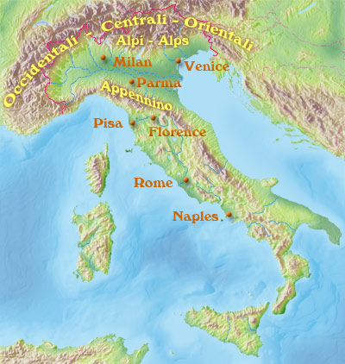
Definition: Geography is the study of the earth’s surface.

Questions to consider:
- What land features are near this civilization?
- Is this civilization isolated from other groups? How does this impact their lives?

Geography Text:
Geography is the study of land on earth. Geographers ask where things are located on the surface of the earth, how places are different from one another, and how people interact with the environment. There are two main branches of geography: human geography and physical geography. Human geography focuses on how people are spread across the world and how they use their land. Physical geographers study patterns of climates, land forms, and water. Geographers also study the linkages between human activity and natural systems. Geographers were, in fact, among the first scientists to sound the alarm that human-induced changes to the environment were beginning to threaten the balance of life itself. They are active in the study of global warming, , deforestation, loss of biodiversity, groundwater pollution, and flooding.
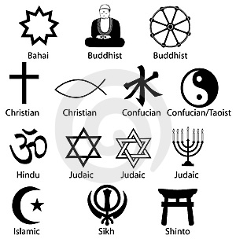

Definition: A societies beliefs about morals and the after life

Questions to consider:
- What are the religious traditions and practices within this civilization?
- How do these religious ideas affect different aspects of daily life?
- What god or gods did they believe in?
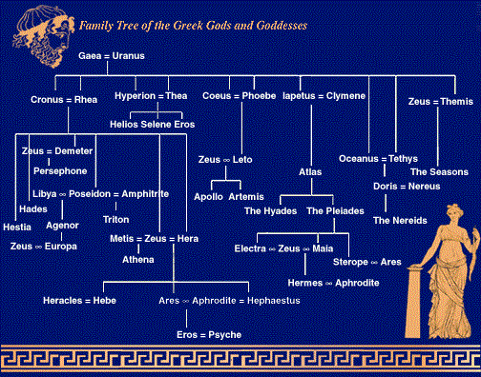
Religion Text:
Throughout history, all civilizations have had a religious systems. A religious system involves a set of beliefs, usually in a god or many gods. It also includes forms of worship. Civilizations often built temples and towers to express their religious beliefs. Religious ceremonies such as human sacrifice, ritual killing or offerings to the gods often took place at these temples. Scholars have learned a lot about ancient religions by studying these buildings.
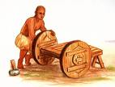

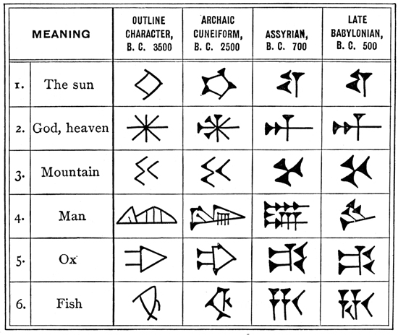
Definition: The lasting works of a society.

Questions to consider:
- What inventions did this civilization create?
- Are these inventions still around today?
- How did these accomplishments change the lives of these people?
Accomplishments Text:
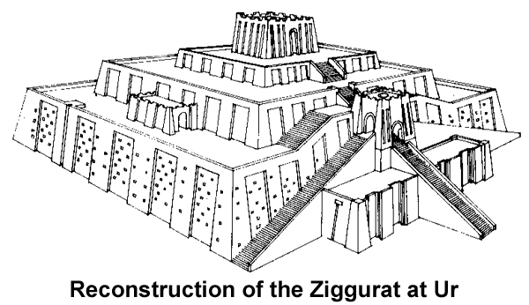
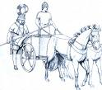
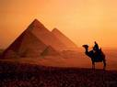
All civilizations create new forms of technology, or practical tools and inventions. Many civilizations figure out new ways to create inventions that make the world an easier place to live (the wheel, writing, farming tools, etc.) Civilizations also have a highly developed culture, including the arts. The arts include creative forms of expression such as painting, architecture, and music. Finally, some civilizations leave behind accomplishments related to thinking and philosophy.
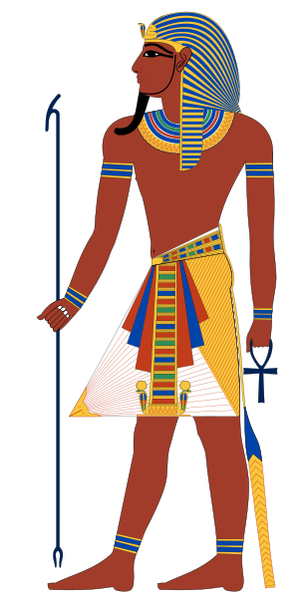

Definition: The people or groups that rule a particular region and how their decisions influence their civilization
Questions to consider:
- Who has power in this civilization?
- What laws exist?
- How do the laws impact the people in this civilization?

Politics Text:
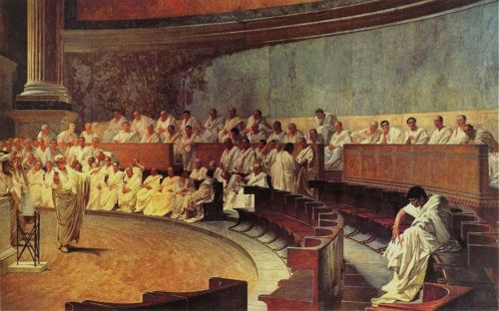
All civilizations have a system of government to direct people’s behavior and help make life orderly. Some Ancient Civilizations were ruled by Kings while others had a democracy where citizens could vote. These leaders made laws for the civilization and led the army. In some civilizations, kings made crazy laws because they were the only person with power. However, people in these civilizations eventually revolted until they had some power too.

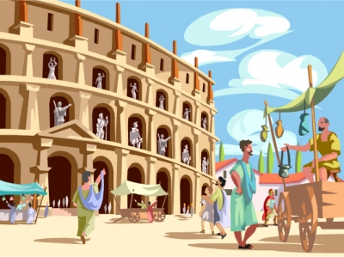
Definition: A system of managing the wealth (money) of a community or region

Questions to consider:
- What kind of money does this civilization have?
- What resources do they create?
- What can they offer when trading with other civilizations?
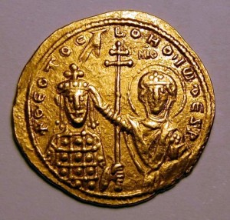
Economy Text:
All civilizations must have a way to feed all of the people that live within their community – this is called a stable food supply. A complex society can ONLY survive if everyone has enough food. Once everyone is fed, however, civilizations can decide what they do with their extra food – do they store it? Do they sell it? Do they trade it for other goods? The economy of most Ancient Civilizations was based on systems of trading in open markets.

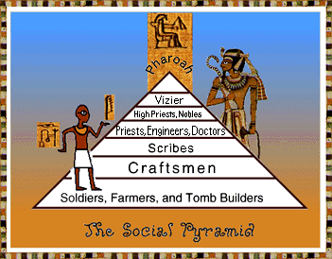
Definition: The way a society or civilization is organized (ex – classes or levels)
Questions to consider:
- Which people are given more power in this civilizations? Why?
- Which people have less power in this civilization? Why?
- How are social levels connected to jobs?

Social Structure Text:
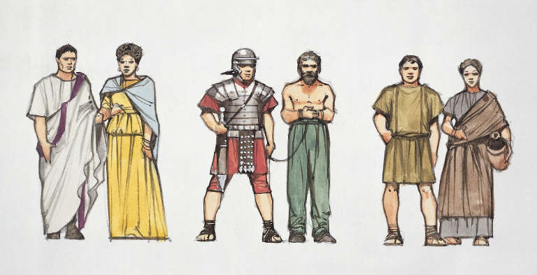
Civilizations usually have a complex organization, or social structure. A social structure includes different jobs and social levels. People at higher levels have greater status (importance) than others. Archaeologists have found evidence that people of different classes lived in most Ancient Civilizations. The people at the top of the social structure in Ancient Egypt were the pharaohs, they had the largest and nicest homes and had the power to make laws. The people in the middle were doctors, scribes, and craftsmen. They lived throughout the cities. The people at the bottom of the social structure in Ancient Egypt were slaves. They lived in their owner’s homes and had no property of their own.

