Unit 5-Cell Division

Mitosis
Chapter 2, Section 3

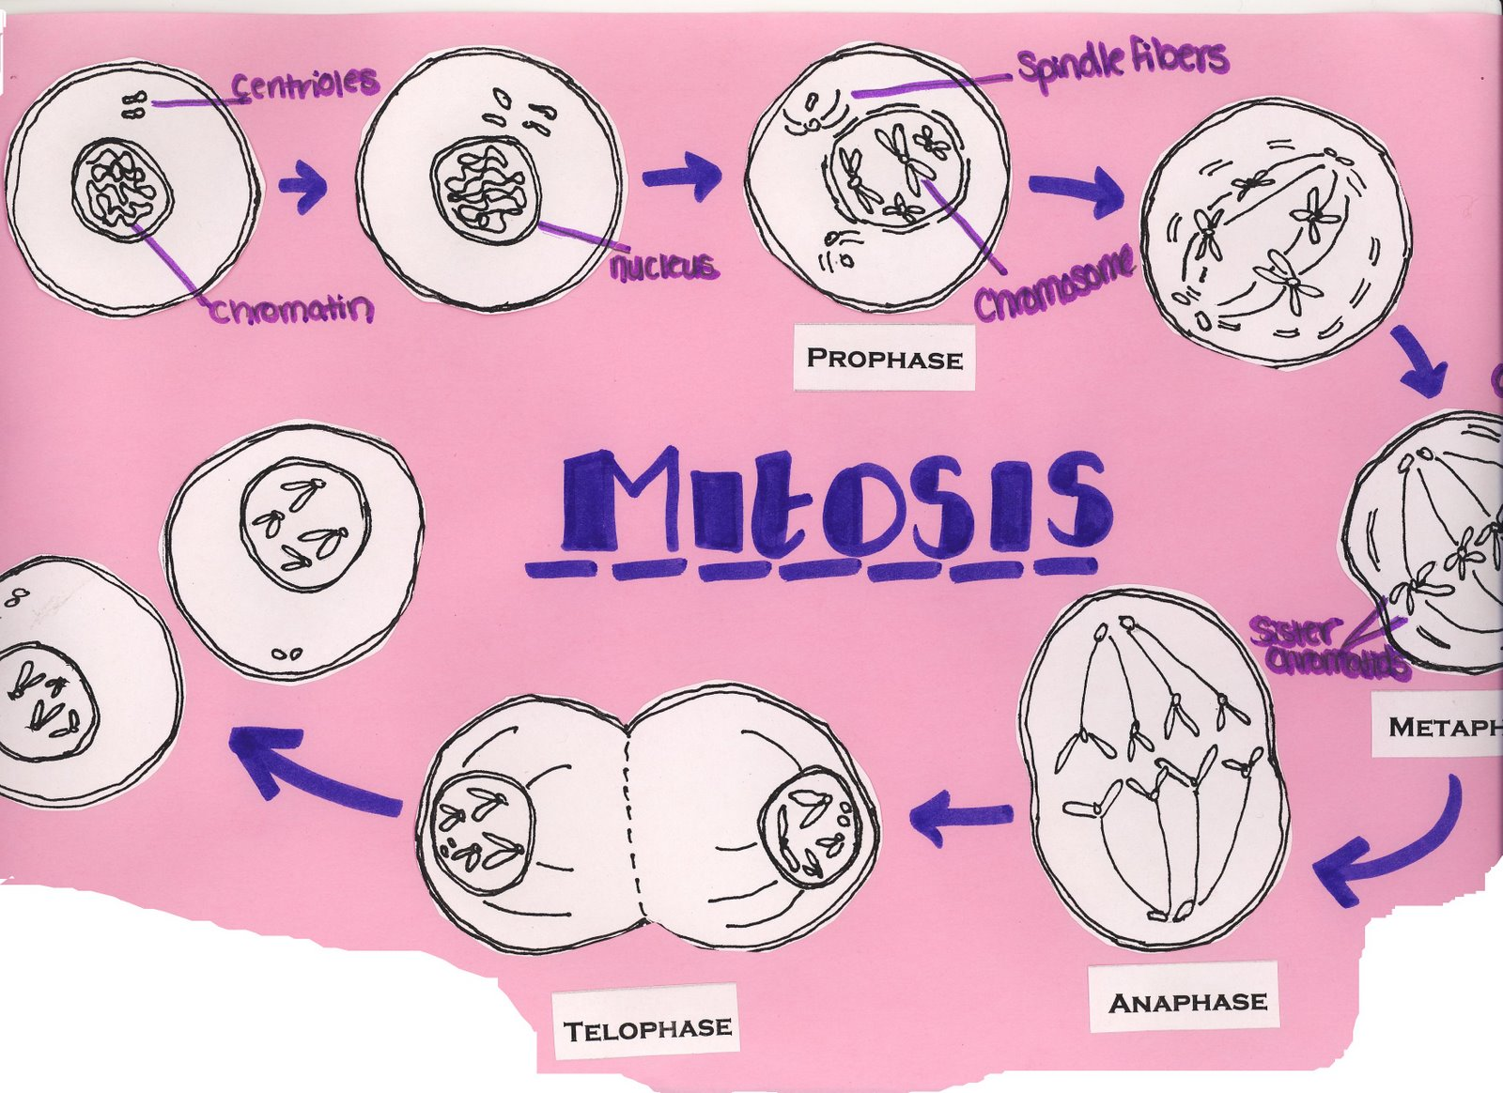

Name _____________________________________________ Period_____

Matter and Energy/Cell Cycle Syllabus
Vocabulary:

Holt Chapter 2 Section 3:

chromosome
homologous chromosomes
cell cycle
interphase
Extra Credit – Complete all of the following for points:

Make a poster, PowerPoint, or movie showing the
Mitosis and cell division Poster
* Posters must be in your own words and NOT a printout from the internet. Graphics may be used from the internet if you cite your sources.

mitosis
prophase
metaphase
anaphase
telophase
cytokinesis

Readings:

Chapter 2 Section 3: Pages 42-45

Assignments:

At home expectations:
  - Learn vocabulary and definitions.
  - Read and complete the “Directed Reading” for the Holt book Ch 2 Reading.
  - Make Flashcards or Two-Column Notes for the vocabulary words.
  - Study for Section Test by reviewing the vocabulary, reviewing the DRA, and completing the Study Guide.
  - Anything not completed in class.
  - Anything not completed in the packet due to absence.

Class work:
- Class Mitosis Activities
- Class Notes.
- Unit Test.

Expected Completion Date: _____________________________________________

Unit Vocabulary Definitions
Vocabulary on Mitosis
Cell Cycle 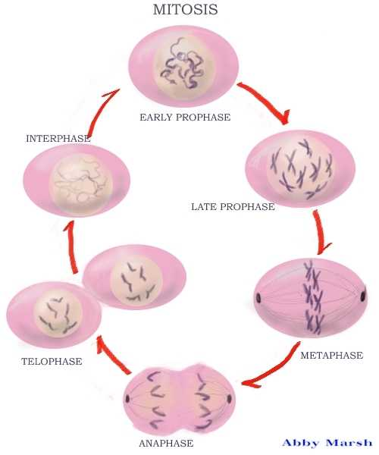 | the life stages of a cell
Chromosomes 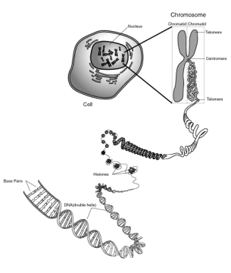 | the structure that contains DNA
Homologous Chromosomes 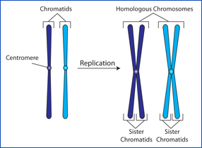 | pairs of similar chromosomes
Mitosis | the process of cell division that forms two identical cells with the same number of chromosomes
Cytokinesis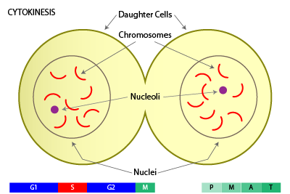 | the division of cytoplasm (rest of the cell divides in two)

Class Notes on the Cell Cycle

The Life of a Cell
Cell Cycle – what is it?
_______________________________________________________________________________________________________________________________________________

What is DNA and how is it organized? _______________________________________________________________________ _______________________________________________________________________________________________________________________________________________________________________________________________________________________ _______________________________________________________________________
Making more Prokaryotes?
______________________________________________________________________________________________________________________________________________________________________________________________________________________________________________________ __________________________________________________________________________________ __________________________________________________________________________________ ____________________________________________________________________________________________________________________________________________________________________

Eukaryotic Cells and Their DNA
________________________________________________________________________ ________________________________________________________________________ ________________________________________________________________________
Making More Eukaryotic Cells
________________________________________________________________________ ________________________________________________________________________ ________________________________________________________________________

Movie Notes…take your own notes in the space below: Write down the most important information that will help you understand the cell cycle and mitosis.
1.What helped you learn about cell division? Circle the best activity:

Reading/notes Flip book movie dance other____________

Why?
______________________________________________________________________ ______________________________________________________________________ ____________________________________________________________________________________________________________________________________________

2.What did not help you learn about cell division? Circle the worst activity:

Reading/notes Flip book movie dance other____________

Why?
______________________________________________________________________ ______________________________________________________________________ ____________________________________________________________________________________________________________________________________________

Any other comments or thoughts you have:

- Describe how and when binary fission happens:
______________________________________________________________________ ______________________________________________________________________ ______________________________________________________________________ ____________________________________________________________________________________________________________________________________________

Draw a picture of it:

- Describe how and when mitosis in an animal cell happens (including the phases):
______________________________________________________________________ ______________________________________________________________________ ______________________________________________________________________ ____________________________________________________________________________________________________________________________________________
______________________________________________________________________ ______________________________________________________________________ ____________________________________________________________________________________________________________________________________________

Draw a picture of it:

3. Describe how and when mitosis in a plant cell happens (including the phases):
______________________________________________________________________ ______________________________________________________________________ ______________________________________________________________________ ____________________________________________________________________________________________________________________________________________
______________________________________________________________________ ______________________________________________________________________ ____________________________________________________________________________________________________________________________________________

Draw a picture of it:

- Describe the main difference for each:
Binary fission ___________________________________________________________________________________________________________________________________________________________________________________________________Animal Cell Mitosis
____________________________________________________________________________________________________________________________________________________________________________________________________________________________________________________________________Plant Cell Mitosis
___________________________________________________________________________________________________________________________________________________________________________________________________

Study Guide
The Cell Cycle, Mitosis and Meiosis
Fill in the correct answer in the box to the right. Use your textbook, notes, packet, entry slip, and vocab sheets.
- the process of cell division that forms two nuclei
- the life stages of a cell
- pairs of similar chromosomes
- the process of cell division in bacteria (a prokaryote)
- What is a prokaryote?
- What is a eukaryote?
- How is the process of cell division different in a plant cell than an animal cell?
- structure that holds chromatids together
- How do body or somatic cells reproduce? Name the process
- What’s the difference between sex cells and body (somatic) cells?
- There are 4 steps or stages in this process that forms two new nuclei
- the division of cytoplasm
- Why do cells need to produce new cells?
- chromosomes are copied during
- forms during plant cell division and contains materials to form cell wall and cell membrane
- where chromosomes are found in eukaryotes
- the four stages of cell division
- stage at which paired chromosomes align at the cell’s equator
- have the same sequence of genes and the same structures
- What happens during cytokinesis in a plant cell?
- stage at which the chromatids separate and move to opposite sides of the cells
- process where the nucleus divides once
- During which stage are chromosomes and organelles copied?
- Reproduction where only one parent cell is needed
- Reproductions where two parent cells are needed
- Where are genes located?
- the structure in which DNA, the hereditary material that controls cell activities, can be found
Notes to yourself:

