Unit 6-Cell Division (M)

Mitosis

Chapter 2, Section 3

+

Meiosis

Chapter 3, Section 3

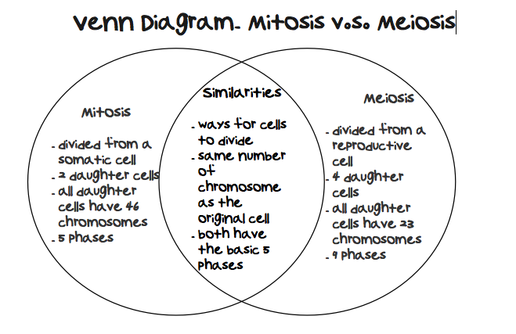

Name _____________________________________________ Period_____

**Matter and Energy/Cell Cycle Syllabus**

**Vocabulary:**

**Holt Chapter 2** **Section 3:**

chromosome

homologous chromosomes

cell cycle

interphase

**Extra Credit – Complete all of the following for points:**

Make a poster showing the

Mitosis and cell division Poster or PowerPoint

* Posters must be in your own words and NOT a printout from the internet. Graphics may be used from the internet if you cite your sources.

mitosis

prophase

metaphase

anaphase

telophase

cytokinesis

**Meiosis Syllabus**

**Vocabulary:**

**Holt Chapter 3** **Section 3:**

homologous chromosomes

meiosis

sex chromosomes

pedigree

**Readings**:

Chapter 3 Section 3: Pages 68-75

**Assignments**:

**At home expectations:**

* 1. Learn vocabulary and definitions.
  2. Read and complete the “Directed Reading A” for the Holt book Ch 2 Reading.
  3. Make Flashcards or Two-Column Notes for the vocabulary words.
  4. Study for Section Quiz by reviewing the vocabulary, reviewing the DRA, and completing the Study Guide.
  5. Anything not completed in class.
  6. Anything not completed in the packet due to absence.

**Class work:**

1. Class Meiosis Activities
2. Class Notes.
3. Unit Quiz.

**Expected Completion Date: _____________________________________________**

**Unit Vocabulary Definitions**

Vocabulary on Mitosis – REVIEW REVIEW REVIEW REVIEW

|  |  |
| --- | --- |
| Cell Cycle http://2.bp.blogspot.com/_UY20coK8Uqo/TSXptxFiMTI/AAAAAAAAAEQ/5p7lBkO7jBM/s1600/mitosis.jpg | the life stages of a cell |
| Chromosomes http://www.ams.org/featurecolumn/images/chromosome.gif | the structure that contains DNA |
| Homologous Chromosomes http://www.hartnell.edu/tutorials/biology/images/homologous_chromosomes.jpg | pairs of similar chromosomes |
| Mitosis http://2.bp.blogspot.com/_UY20coK8Uqo/TSXptxFiMTI/AAAAAAAAAEQ/5p7lBkO7jBM/s1600/mitosis.jpg | the process of cell division that forms two identical cells with the same number of chromosomes |
| Cytokinesishttp://essayweb.net/biology/images/celldivision/cytokinesis.png | the division of cytoplasm (rest of the cell divides in two) |

Vocabulary on Meiosis

|  |  |
| --- | --- |
| Asexual reproduction (1 parent cell) | Reproduction where 1 cell copies and splits into two identical cells with the full number of chromosomes |
| Sexual reproduction (2 parent cells) | Reproduction where 2 parent cells with ½ the number of chromosomes (sex cells) combine to form offspring with the full number of chromosomes |
| Meiosis http://upload.wikimedia.org/wikipedia/commons/thumb/9/9a/Meiosis_Overview.svg/300px-Meiosis_Overview.svg.png | process that produces cells with half the chromosomes (sex cells) |
| Mitosis http://2.bp.blogspot.com/_UY20coK8Uqo/TSXptxFiMTI/AAAAAAAAAEQ/5p7lBkO7jBM/s1600/mitosis.jpg | process where the nucleus divides once |
| Selective breeding http://www.wisdompanelpro.com/view/bin/images/dog_history_tree.jpg | process used to create bigger and better offspring |
| Pedigreehttp://upload.wikimedia.org/wikipedia/commons/thumb/9/9c/Pedigree-chart-example.svg/769px-Pedigree-chart-example.svg.png | diagram used to trace traits in a family |

Class Notes on Meiosis

**The Life of a Cell**

Asexual Reproduction – what is it?

* __________________ is needed
* Parent cell divides making _________ exact copies through _____________
* ______________ in your body and ___________________ organisms reproduce this way.

Sexual Reproduction – what is it?

* ______________________ are needed
* Parent cells (called _______________) join to make an offspring different from both parents

What is Meiosis?

* Copying process that produces cells with ___________ the usual number of ____________.
* Each sex cell receives _________________ of each homologous pair – ______________

How many chromosomes does a human egg cell have? _____________________________________

Where are genes located? _____________________________________________________________

What did Walter Sutton observe?

* Steps of meiosis explained _____________results.
* For dominant and recessive alleles for seed shape example…
* Only _____ genotype was possible – all ________formed by the male parent during meiosis had wrinkled-seed allele; female parent’s _________ had round-seed allele
* Meiosis helped explain inherited characteristics!

What are sex chromosomes and how do they work?

* Carry ________________ that determine sex (male or female)
* Humans – females have 2 ___ chromosomes (____) and males have 1 ___ and 1 ____Y (____)

**During Meiosis - one of each of the chromosome pairs ends up as a sex cell.**

Female chromosomes _____________ Male chromosomes _____________

**Females have XX and each egg gets an X.**

**Males have XY and each sperm gets either an X or a Y**

**An egg fertilized with an X sperm will produce a female and a Y sperm will make a male.**

**MC900438223[1] MC900438231[1]**

**___ from mom + ___ from dad = ___ ___ from mom + ___ from dad = ___**

**MALES=__________________ FEMALES=_____________________**

What are sex-linked disorders?

* Colorblindness is carried on the _______ chromosome.
* Gene for this disorder is ___________, so men are more likely to have sex-linked disorders
* Sex-linked disorders are carried on the _______ ___________ (X or Y).

**Y chromosome doesn’t carry all the genes of an X.**

**Females have 2 X chromosomes so they have 2 copies of gene (act as a backup)**

**Males only have 1 copy of each (no backup)**

What are two examples of a sex-linked disorder?

What is selective breeding?

* Organisms with desirable _________________ are mated to produce a more desirable offspring.

Examples:

Study Guide - MOD

**The Cell Cycle, Mitosis and Meiosis**

**Fill in the correct answer in the box to the right. Use your textbook, notes, packet, entry slip, and vocab sheets.**

|  |  |
| --- | --- |
| 1. **the life stages of a cell** |  |
| 1. **pairs of similar chromosomes** |  |
| 1. **What is a prokaryote?** |  |
| 1. **What is a eukaryote?** |  |
| 1. **the process of cell division in bacteria (a prokaryote)** |  |
| 1. **How do body or somatic cells reproduce? Name the process** |  |
| 1. **Name the process that produces sex cells?** |  |
| 1. **What’s the difference between sex cells and body (somatic) cells?** |  |
| 1. **the division of cytoplasm where the cell splits into two new cells** |  |
| 1. **Why do cells need to produce new cells?** |  |
| 1. **chromosomes and organelles are copied during this stage in the cell cycle** |  |
| 1. **forms during plant cell division and contains materials to form cell wall and cell membrane – this happens during cytokinesis in a plant cell** |  |
| 1. **organelle where chromosomes are found in eukaryotes** |  |
| 1. **process that makes cells with half the number of chromosomes** |  |
| 1. **process where the nucleus divides once** |  |
| 1. **Reproduction where only one parent cell is needed** |  |
| 1. **Reproductions where two parent cells are needed** |  |

|  |  |
| --- | --- |
| 1. **How are sex cells different from other human cells?** |  |
| 1. **If a sex cell started with 14 chromosomes, how many chromosomes would it have after going through meiosis?** |  |
| 1. **During meiosis, how many times does the cell divide?** |  |
| 1. **Where are genes located? On what structure** |  |

**Notes to yourself:**