Unit 9

Bacteria and Viruses
Chapter 2
(Holt Book A)

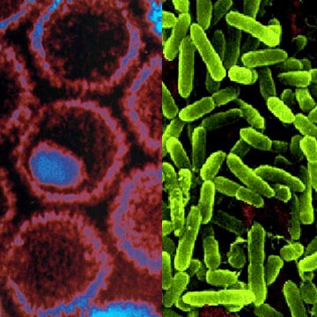

Chapter 2 Section 1: Bacteria and Viruses
Chapter 2 Section 2: Bacteria’s Role in the World
Chapter 2 Section 3: Viruses

Name _____________________________________________ Period_____

Bacteria and Viruses Syllabus

Vocabulary:

SECTION 1: BACTERIA AND ARCHAEA

prokaryote
binary fission
endospore
cyanobacteria
flagella

SECTION 2: BACTERIA’S ROLE IN THE WORLD
bioremediation
nitrogen fixation
antibiotic
pathogenic bacteria
genetic engineering

SECTION 3: VIRUSES
virus
host
parasite

Readings:

Chapter 2 Section 1: Pages 22-29
Chapter 2 Section 2: Pages 30-33
Chapter 2 Section 3: Pages 34-37

Assignments:

At home expectations: (CHECK OFF WHEN COMPLETED)
  - Learn vocabulary and definitions.
  - Read the chapter and complete the “Directed Readings” for Section 1, 2 and 3.
  - Make Flashcards or Two-Column Notes for the vocabulary words – study 2 mins EVERY DAY!
  - Complete Yogurt Lab questions
  - Complete Chapter Review
  - Study for Chapter Test by reviewing the vocabulary, reviewing the DRA, Chapter Review, Study Guide, and the notes and activities.
  - Completed anything not completed in class.
  - Anything not completed in the packet due to absence. Dates of absence_________________

Class work:
- Class Notes.
- Video Notes.
- Bacteria Webquest Group Projects and Presentations/Notes
- Classroom demonstrations/activities on bacteria and viruses
- Bacteria or Virus worksheet
- Yogurt Lab
- Unit Test.

Expected Completion Date: _____________________________________________

Extra Credit - 5 Pts
- Make a word find (with answer key) or crossword puzzle that contains ALL the vocabulary word for the unit. Ask before you start your project.
http://puzzlemaker.discoveryeducation.com/

Be as creative as you would like!

Unit Vocabulary Definitions

SECTION 1: BACTERIA AND ARCHAEA Pages 22-29
- prokaryote: an organism that consists of a single cell that does not have a nucleus
- binary fission: a form of asexual reproduction in single-celled organisms by which one cell divides into two cells of the same size
- endospore: a thick-walled protective spore that forms inside a bacterial cell and resists harsh conditions
- cyanobacteria: bacteria that contain chlorophyll and can undergo photosynthesis
- flagella: a hair-like projection used for locomotion

SECTION 2: BACTERIA’S ROLE IN THE WORLD Pages 30-33
- bioremediation: the biological treatment of hazardous waste by living organisms
- nitrogen fixation: process in which nitrogen in the air is transformed into a form that plants can use
- antibiotic: medicine used to kill bacteria and other microorganisms
- pathogenic bacteria: bacteria that cause disease
- genetic engineering: when humans change the genes of any living thing

SECTION 3: VIRUSES Pages 34-37
- virus: a microscopic particle that gets inside a cell and often destroys the cell
- host: an organism from which a parasite takes food or shelter
- parasite: an organism that lives in or on a host, it obtains nourishment from the host without benefiting or killing the host

Section 1 - Class Notes on Bacteria

Characteristics of Bacteria and Archaea
__________________________________________________________________________________ __________________________________________________________________________________ __________________________________________________________________________________
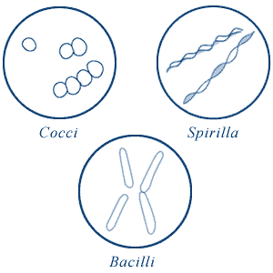
Three Shapes of Bacteria
______________________________________________________________________________________________________________________________________________________________________________________________________________________________________________________

* ___________________ are whip-like ______________ that help move a bacteria

No Nucleus!
____________________________________________________________________________________________________________________________________________________________________

Prokaryotic Reproduction
____________________________________________________________________________________________________________________________________________________________________

Endospores
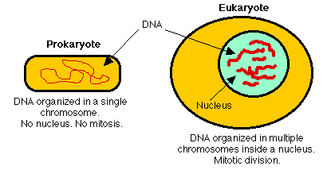
____________________________________________________________________________________________________________________________________________________________________

Domain Bacteria – Classification of Bacteria
__________________________________________________________________________________
__________________________________________________________________________________Consumers- ________________________________________________________________________ Producers - ________________________________________________________________________
Decomposers - _____________________________________________________________________
Cyanobacteria - _____________________________________________________________________ __________________________________________________________________________________ ________________________________________________________________________________

Domain Archaea – Harsh Environments
__________________________________________________________________________________
__________________________________________________________________________________Thermophiles-______________________________________________________________________ __________________________________________________________________________________ Halophiles - ________________________________________________________________________ __________________________________________________________________________________
Methane makers - ___________________________________________________________________ __________________________________________________________________________________

Section 2 - Class Notes on Bacteria’s Role in the World

Good for the Environment
__________________________________________________________________________________ __________________________________________________________________________________

Nitrogen Fixation
____________________________________________________________________________________________________________________________________________________________________

Recylcing
____________________________________________________________________________________________________________________________________________________________________

Cleaning up - Bioremediation
____________________________________________________________________________________________________________________________________________________________________

Good for People
____________________________________________________________________________________________________________________________________________________________________

Bacteria in your Food
__________________________________________________________________________________
__________________________________________________________________________________ __________________________________________________________________________________

Making Medicine
__________________________________________________________________________________
__________________________________________________________________________________

Insulin - ___________________________________________________________________________

Genetic Engineering - ________________________________________________________________

Harmful Bacteria
__________________________________________________________________________________ __________________________________________________________________________________
Pathogenic bacteria - _________________________________________________________________ __________________________________________________________________________________
Diseases in other organisms
____________________________________________________________________________________________________________________________________________________________________

Section 3 - Class Notes on Viruses

Viruses
__________________________________________________________________________________ __________________________________________________________________________________

Very Small - _______________________________________________________________________ Change rapidly -____________________________________________________________________
Non-living - _______________________________________________________________________ _________________________________________________________________________________ _________________________________________________________________________________
Why don’t antibiotics work on viruses? - ________________________________________________ __________________________________________________________________________________ __________________________________________________________________________________

What’s the harm in trying to treat viruses with antibiotics?- ______________________________________________________________________________________________________________________________________________________________________________________________________________________________________________________

Classifying Viruses – Two ways
__________________________________________________________________________________ Shape - ___________________________________________________________________________ Genetic material-____________________________________________________________________

Four Basic Shapes of Viruses

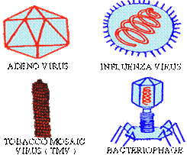
Spheres – HIV virus
Crystals – polio virus
Cylinders – tobacco plants
Spacecraft - bacteria

The Lytic Cycle - ___________________________________________________________________ __________________________________________________________________________________ __________________________________________________________________________________

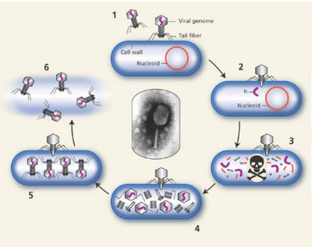
Draw your own version below:

A Time Bomb
__________________________________________________________________________________
__________________________________________________________________________________Lysogenic cycle - ___________________________________________________________________ __________________________________________________________________________________

Treating Viruses
__________________________________________________________________________________
__________________________________________________________________________________Antiviral medications-________________________________________________________________ __________________________________________________________________________________
Vaccinations - ______________________________________________________________________ __________________________________________________________________________________
Chicken pox - ______________________________________________________________________

Watch the video clip on how a virus spreads then we’ll discuss (see NPR link on viruses from edline)
Good practices - ___________________________________________________________________ ____________________________________________________________________________________________________________________________________________________________________

Video Notes - Bacteria – Friends or Enemies ??

- (0:51) There are _____________________ of bacteria in your mouth alone.
- (1:09) It would take __________________________ of them laying end to end to equal just a centimeter.
- (1:41) Bacteria are the ____________________, ____________________ organisms and they can be found (name 2 places) _________________________ and __________________________.
- (2:11) Your body is made up of _____________________ of cells.
- (2:11) The word bacterium is the ____________________ form of bacteria.
- (3:09) Bacteria’s hereditary material is located within the _______________.
- (3:30) The ___________________ is what gives bacteria it’s shape and help protect it.
- (3:56) Some bacteria have a whip like structure called a ______________ to propel it through liquid.
- (5:00) Some cells reproduce very quickly, sometimes every _______________________.
- (6:22) A wax like mass called a ____________________ is made up of trillions of bacteria.
- ( 6:48) Some bacteria are brightly colored due to the _________________ found in their body.
- (7:20) Freezing and ____________________ will kill nearly all bacteria.
- (8:40) Bacteria eat just about any ______________________ matter.
- (9:40) Without bacteria, many forms of life might not be able to ___________________.
- (10:40) Many cities use bacteria to help break down _____________________.
- (12:15) Bacteria can digest oil into _______________________ substances.
- (13:07) ___________________ blood cells help protect us from bacteria.
- (14:40) In the 1900’s Alexander Fleming discovered a powerful drug called ________________, which weakens the ________________________ of bacteria, causing them to explode as they grow in size.
- (15:36) Scientists create better medicines and new and useful products by altering the ______________ code.
- (17:00) Most scientists thing the risk of genetic engineering of bacteria harming humans is __________.
- (18:00) Every bacterium is surrounded by one or more _______________________ layers.
In Conclusion - It is a good thing that vast majority of bacteria are harmless, and most benefit humans, because bacteria will always be _________________.

Life Science: Viruses Movie

Discussion Questions
• What is a virus, and how does it reproduce?

• How does the body fight a virus? What are antibodies?

• What was Edward Jenner’s discovery, and how did it lead to the development of vaccines?

• How does a vaccine work?

• Who invented the polio vaccine—the first vaccine that didn’t make people sick?

• How can new viruses emerge?

• What viral disease affects one in 100 people between the ages of 15 and 49 and is especially prevalent in Africa?

• What is one way new viruses are being monitored and controlled?

Virus, Bacteria,
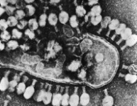
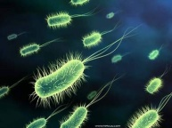
or both???

Fill in the space below on hints you are given. The first one is done for you.
 | Hint | Virus, Bacteria, or Both ???
 | Can use flagella to move. | Bacteria
 | 5 billion can fit in a drop of blood.
 | Are one celled.
 | Can only live in a cell that is used as a host.
 | Vaccinations work against these.
 | Does not have a nucleus.
 | Can be grouped by the type of disease they cause.
 | There are more of these on earth than all other living things combined.
 | Reproduce by binary fission.
 | Chickenpox is caused by this.
 | Antibiotics do not work on these.
 | Can sometimes form an endospore.
 | Sometimes are used in bioremediation.
 | Are classified in the way they get food.
 | These go through the lytic cycle.
 | Some of these can make their own food.
 | These do not eat, grow, or break down food.
 | These help fix Nitrogen for plants
 | Cause many of the food spoilage problems.
 | Many antibiotics are made by these.

*BONUS: Which of the 2 pictures above is a virus? How can you tell?
Chapter Review for “Bacteria and Viruses” p. 40
You may also attach notebook paper, or type your answers.
Using Key Terms
- _______________________________________________________________________________________
__________________________________________________________________________________________
- ___________________________________
- ___________________________________
- ___________________________________
Multiple Choice – Write the letter AND the answer in the blanks.
- ______ - _______________________
- ______ - _______________________
- ______ - _______________________
- ______ - _______________________
- ______ - _______________________
- ______ - _______________________
- ______ - _______________________
- ______ - _______________________
Short Answer
Skip 13
- ________________________________________
- 1) ______________________________________________________
2) _____________________________________________________
- ______________________________________________________________________________________________________________________________________________________________________________
- ______________________________________________________________________________________________________________________________________________________________________________
- Skip
- _____________________________________________________________________________________________________________________________________________________________________________________________________________________________________________________________________
- _____________________________________________________________________________________________________________________________________________________________________________________________________________________________________________________________________
- _____________________________________________________________________________________________________________________________________________________________________________________________________________________________________________________________________
Interpreting Graphics
- __________________
- __________________
- __________________
- __________________

Study Guide – Bacteria and Viruses
This contains most, but not all of the concepts and vocabulary. Review your film notes, fill in notes, vocab and class materials to also study.
List ways bacteria are helpful (and examples of each) – name as many ways as you can (come up with a minimum of 3!)

How do viruses multiply?

What are pathogenetic bacteria?

How do we make antibiotics?

Cleaning up hazardous wastes like oil spills with bacteria is called?

These can only reproduce within a hosts’ cell – what are they?

What is a type of medicine that stops viruses from reproducing?

3 shapes of bacteria and what they look like (draw them and name them)

A cell without a nucleus is called:

Insulin is made by these

Bacteria can be engineered to make:  (list as many as you can) | 1. 4.  2. 5.  3. 6.
An example of using bacteria to fight other bacteria

Process of plants converting nitrogen to a form plants can use

Bacteria that contain chlorophyll

These live in extreme environments

Ways Archaea and bacteria are different

Flamingos get their pink color from this

Bacteria are classified by:
One way to prevent viral infections

All bacteria are made of ______ cell

Describe the 4 stages of the lytic cycle?

What is the first stage of the binary fission?

What is the second stage of the binary fission?

What is the third stage of the binary fission?

What is the fourth stage of the binary fission?

Hair like parts that propel bacteria

Cells that have a nucleus

Differences between eukaryotes and prokaryotes:
5 ways viruses NOT like living things?
How ARE viruses like living things?
2 types of genetic material in viruses

Scientists don’t know how many types of viruses exist because:

How are the lytic and lysogenetic cycle different in viruses?
Prokaryotes reproduce by

Bacteria can infect:
(List as many organisms as you can!)

bioremediation - What is it and give an example.

antibiotic - What is it and what does it do?
pathogenetic bacteria – What do they do?

genetic engineering – What is it and give an example.

binary fission – What goes through this process and describe the process.

Endospore – Describe what it is.

In the space below, organize your notes in the best way that you’ll remember the material you’re having difficulty with:

