Wilson’s 14 Points and the Treaty of Versailles
Directions: Using pages 684-689 of the textbook, answer the following questions completely. Thorough answers ensure success on next week’s test.
- Define treaty:

- Describe post-war Europe in one sentence.

- What was the purpose of Wilson’s Fourteen Points?

- Define Self-Determination:

- What was Wilson’s final (and most important) point?

- What was the purpose of the League of Nations?

- Define reparations

- Who had to pay reparations after the war?

- Why did the U.S. Senate reject the Treaty of Versailles and the League of Nations?

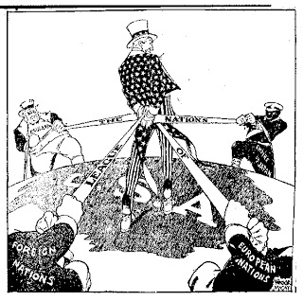
Does this cartoon express a view for or against joining the League of Nations? How do you know?

