Harlem Renaissance
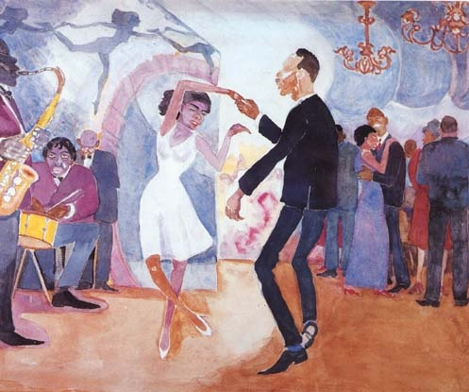
What was the Harlem Renaissance and when did it happen?
The Harlem Renaissance was a name given to the social, artistic, and cultural outbreak of African Americans in Harlem. This was a time when African Americans moved to Harlem and brought with them new talent. The Harlem Renaissance occurred between 1918 and 1937.

Who was involved with the Harlem Renaissance?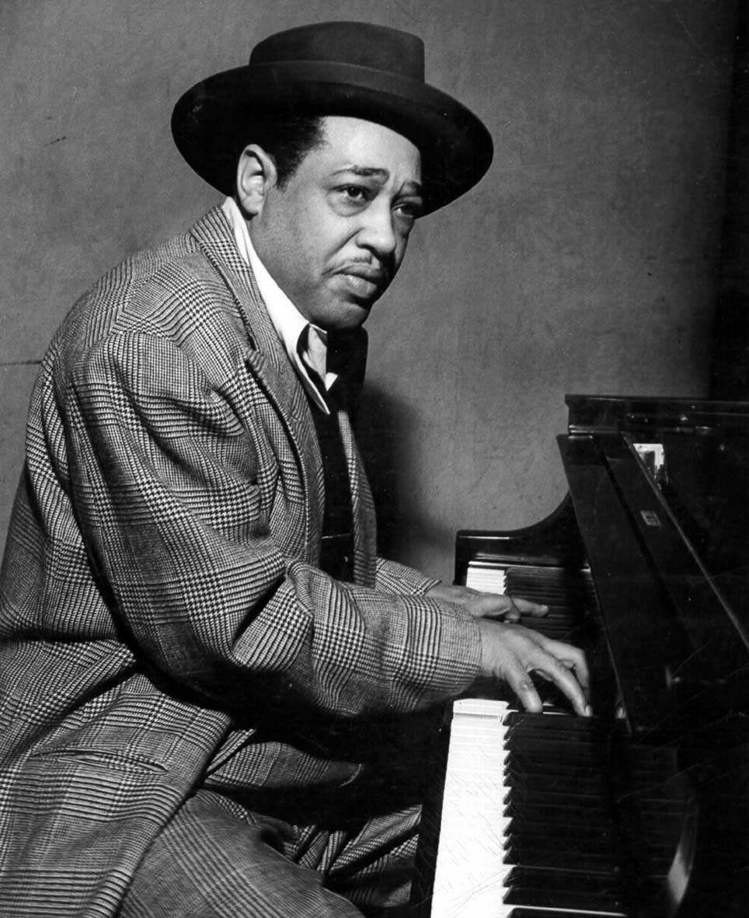
African Americans and those who believed in equal rights for all people were strongly involved in the Harlem Renaissance. Some important people that were involved were Langston Huges, Duke Ellington, and Billie Holiday. All of these artists were some of the most influential people during the Harlem Renaissance. They shaped this movement which soon lead to even wider acceptance of Africans.
What did the Harlem Renaissance do for African Americans? Why did it Exist?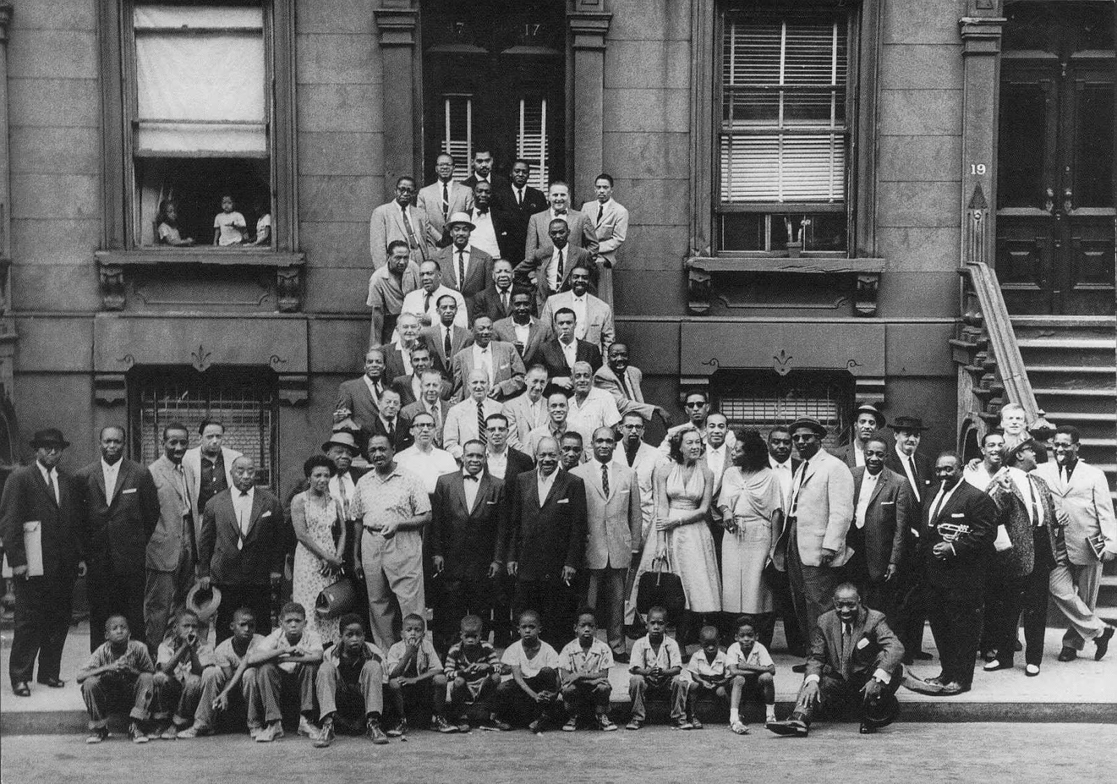
The Harlem Renaissance existed because newly freed slaves in the South were still discriminated on even after World War I. Southern lawmakers enlisted Jim Crow Laws to ensure that the freedom of African Americans will remain limited. All of the African Americans wanted to start over and build a new life but they could not do that in the South so they had to migrate to Harlem. The Harlem Renaissance had an enormous affect on the civil rights movement. It, in some ways, ushered it. The Harlem Renaissance also created a new cultural identity for African Americans. It opened many doors for blacks and gave them many new opportunities for a better life.

The Harlem Renaissance is a great example of the immense change and resistance to change that occurred in the 1920’s. This is because many Americans in the South and even a few Northerners did not welcome African Americans in their cities and towns. They resisted this big change. The Harlem Renaissance is also a great example of change in the 1920’s because of the impact it had on America. It greatly opened the eyes of all of the Americans who still treated blacks unfairly. It also changed American culture. Americans were now listening to jazz music and reading poetry about the Great Migration.

Charles Lindberg
- Charles Lindbergh was a pilot who was considered the biggest hero in the 1920’s
- On the morning of May 20, 1927, Lindbergh loaded his plane, Spirit of St. Louis, with sandwiches, personal papers, and fuel. He took off from long Island, New York. He flew about 33 and a half hours until he reached Paris, France. He completed the very first nonstop solo flight across the Atlantic Ocean. He traveled over 3,500 miles.
- Charles Lindbergh has to do with the 1920’s being a decade of America changing. This is because he showed that it is possible to do these types of flights alone. In 1932, Amelia Earhart became the first female pilot to fly across the Atlantic Ocean. She would have not completed that flight without Charles Lindbergh’s previous one. He changed the whole course of history because he showed what America is capable of doing. The 1920’s were times of heroic worship. Charles Lindbergh connects back to this idea because he took a big risk. At times he flew only ten feet above the waves so he could continue his journey through the fog. The trip was very dangerous. He was given a medal of high honor because of his flight.

http://www.bing.com/videos/search?q=video%20clips%20of%20charles%20lindbergh's%20flight%20and%20parade&qs=n&form=QBVR&pq=video%20clips%20of%20charles%20lindbergh's%20flight%20and%20parade&sc=0-0&sp=-1&sk=#view=detail&mid=B2E3A3AB184C729FFF31B2E3A3AB184C729FFF31

Cited Sources:
- Call to Freedom, page 714

Research document Georgia O’keeffe

Who was involved with my term?

Georgia O’keeffe
Georgia’s younger sister Anita
Alon Bement the art professor
Friend of Georgia’s Ansel Adams

What did your term or people associated with your term do?

Georgia O’keeffe was an artist
Georgia was against painting things realistic. She wanted to expand the art that she painted
Georgia’s younger sister took art classes with her
Alon Bement was Georgia’s first art professor when she was young. She took art classes with her sister
Georgia’s friend was a photographer. She took pictures of Georgia’s art work

What places are associated with your term?

West Virginia-state where Georgia took art classes
Williamsburg Virginia- specific town in where Georgia took art classes
Sun Prairie, Wisconsin- where Georgia grew up

What dates are important regarding your term?

1908-the year Georgia gave up her dream of being a professional artist
1953-O’keeffe had improved much since her days of giving up
she lived in Williamsburg taking art classes then moved in 1912 to Charlottesville, Virginia
November 15, 1887- Georgia O’keeffe’s date of birth

Why did your term exist?

Because Georgia O’keeffe was a woman artist in the 1920s which was a hard time for women artists. They had to paint specific things and were made to be certain painters. The fact that Georgia O’keeffe went against that ritual and out of her way to paint exactly what she wanted is inspiring.

ACLU
Who was involved with you trem?
- Norman Thomas was one of the early leaders
- Roger Baldwin found the ACLU

What did your term or people associated with your trem do?
- works in the courts to defend and preserve individual rights and liberties guaranteed to all people in this country by the Constitution and laws of the United States.

Important dates regarding your term?
- July 1925, scope trail

Why did your trem exist?
- to preserve rights and individual liberties

My term was resisting change because they did not want people to lose their rights.

Topic research: Model T and the Assembly line

Henry Ford had a goal of making automobiles that everyone could afford. The Ford Model T was the answer to that goal. The creation of the assembly line by Henry Ford at his Highland Park Plant was introduced on December 1, 1913, revolutionizing the automobile industry and the concept of manufacturing worldwide. The cost of the first Model T was set at $850, which would be about $21,000 in today’s currency. It was cheap, but not cheap enough so Ford needed to find a way to cut down the price even further for everyone to be able to afford it.

Ford consulted with Frederick Taylor, creator of scientific management, to examine the most efficient modes of production. Ford had previously observed the assembly line concept in slaughterhouses in the Midwest and was also inspired by the conveyor belt system that was common in many grain warehouses in that region; he wished to incorporate these ideas with the new information Taylor suggested to implement a new system in his own factory. The immediate impact of the assembly line was amazing. The use of interchangeable parts allowed for continuous work flow and more time on task by laborers. Worker specialization resulted in less waste and a higher quality of the end product. Sheer production of the Model T shot through the roof. The production time for a single car dropped from over 12 hours to 93 minutes due to the introduction of the assembly line. Ford’s 1914 production rate of 308,162 eclipsed the number of cars produced by all other automobile manufacturers combined. These concepts allowed Ford to increase his profit margin and lower the cost of the vehicle to consumers.

The cost of the Model T would eventually drop to $260 in 1924, the equivalent of about $3500 today. The assembly line also drastically altered the lives of those in Ford’s employ. The work day was cut from 9 hours to 8 hours so that the concept of the three shift workday could be implemented with greater ease. Although hours were cut, workers did not suffer from lower wages; instead, Ford doubled the existing industry standard wage and began paying workers $5 dollars a day. The production of the Model T ended in 1927. This term has to do with the 1920s being a decade of America changing because affordable cars were being produced and cars were changing America’s way of transportation.

Works Cited
"History.com." History.com. A&E Television Networks. Web. 11 Dec. 2014. <http://history.com/>.

Rosenberg, Jennifer. "20th Century History: Events and People of the 1900s." Web. 13 Dec. 2014. <http://history1900s.about.com/>.
