Grade 8 Social Studies Writing Performance Task Spring 2015
Should the United States Have Gotten Involved in the Vietnam War?
Overview:
Over the next two days, you will examine eight written and visual sources on American involvement in the war in Vietnam, taking notes on these sources. These sources will provide an overview of perspectives on this compelling topic. Finally, you will work individually to write a full-length argumentative essay, developing and supporting a claim to answer the question.
Day One (40 minutes)
- Read and examine the written and visual sources; video will be shown on the screen
- Take notes on these sources – this will be very helpful in planning and writing your essay. You may also write on, underline, or highlight print sources as needed.
- Graphic organizers are provided to help organize your ideas (You are not required to complete these and they will not be scored)
Day Two (40 minutes)
- Review your notes and sources; you may refer to your print sources at any time.
- Write the first draft of an argumentative essay, following the directions below:
Your Assignment:
The Vietnam War was a long, costly armed conflict that involved the communist regime of North Vietnam and its allies against South Vietnam and its principal ally, the United States. The war began in 1954 (though conflict in the region stretched back to the mid-1940s), after the rise of Ho Chi Minh and his communist party in North Vietnam. The U.S. slowly became more involved and it continued against the backdrop of an intense Cold War between the United States and the Soviet Union. By 1969, more than 500,000 U.S. military personnel were involved in the conflict. More than 57,000 Americans were killed in the war. Growing opposition to the war in the U.S. led to bitter divisions among Americans. The United States withdrew in 1973 without achieving victory, and in 1975, communist forces seized control of the south and ended the war. Using information from the accompanying sources, as well as your knowledge of American History, it is your assignment to write an argumentative essay answering the following compelling question:
Should the United States have gotten involved in the Vietnam War?
Guidelines: In your essay, be sure to:
- Address all aspects of the task.
- Support your claim (thesis) with relevant and well-chosen evidence: facts, definitions, details, and/or quotations, incorporating information from the documents, as well as outside information.
- Use a logical and clear plan of organization, including an introduction, body paragraphs, and conclusion.
- Adhere to the conventions of the English language in sentence structure, grammar, spelling, etc. while using appropriate vocabulary for an academic purpose.
Source One
A Dubious Crusade
James A. Warren
Dubious: Hesitating or doubting; uncertain; questionable
The Vietnam War was the longest and most controversial conflict in American history. Because the government of the United States never officially called the conflict a war, it is hard to say just when it began. The first American deaths in Vietnam occurred in 1959. Although very few Americans died in the jungles of Southeast Asia until 1965, when the first combat units were sent there, the U.S. government supplied the French with money and equipment to fight the Vietnamese communists in their war, which began in 1946, and continued to support anticommunists in Vietnam up to 1975.
All wars are complex, brutal affairs that test the endurance of soldier and ordinary citizen alike. The Vietnam War, in which the United States, its allies, and South Vietnam fought against rebels within South Vietnam, called the Vietcong and communists from North Vietnam, tested the endurance and the understanding of the American people in ways that other wars have not.
As an episode of military history, Vietnam is really just beginning to be explored, and its importance goes far beyond military history. The American experience in Vietnam provides us with a wealth of clues and insights about modern American history and American values. When President John F. Kennedy was laying the groundwork for direct Ameican intervention in Vietnam in the early 1960s, the United States had reached the height of its power and self-confidence. We were the unchallenged leaders of the free world. There was a belief among the nation’s leaders that the United States was invincible, that it had not only the political and military might to do what it wanted where it wanted, but also the moral authority to do so.
In 1975, Americans watched on television the humiliating evacuation of Saigon, the capital city of South Vietnam. The surrender of the city to the communists ended a terrible era in our history – an era that changed us. America was an entirely different nation than it had been back in the early 1960s. We were no longer so sure of our path, no longer confident that we had the answers to all the important questions.
The war had come close to tearing the nation apart. The American public no longer trusted its government. The armed forces of the nation had become demoralized (dispirited) and fragmented (broken apart). The soul and conscience of the nation had been deeply wounded. More than 57,000 men had sacrificed their lives in what is now though to be a dubious crusade.

Source Two
Timeline: The War in Vietnam
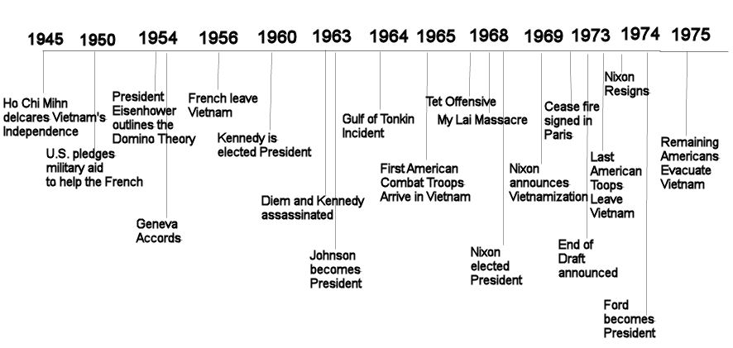

Source Three
Excerpt from a Letter written by U.S. President John F. Kennedy to
President Ngo Dinh Diem of South Vietnam: December 14, 1961

Dear Mr. President,
I have received your recent letter in which you described so cogently (clearly) the dangerous conditions caused by North Vietnam’s effort to take over your country…We have been deeply disturbed by the assault on your country…the deliberate savagery of the Communist programs of assassination, kidnapping, and wanton violence became clear.
In response to your request, we are prepared to help the Republic of (South) Vietnam to protect its people and preserve its independence. We shall promptly increase our assistance to your defense effort as well as help relieve the destruction…which you describe. I have already given the orders to get these programs underway.
The United States, like the Republic of (South) Vietnam, remains devoted to the cause of peace and our primary purpose is to help your people maintain their independence.

Source Four
The Gulf of Tonkin Resolution, 1964
Whereas the United States is assisting the peoples of southeast Asia to protect their freedom and has no territorial, military, or political ambitions in that area, but desires only that these people should be left in peace to work out their destinies in their own way: Now, therefore be it
Resolved by the Senate and House of Representatives of the United States of America in Congress assembled, That the Congress approves and supports the determination of the President, as Commander in Chief, to take all necessary measures to repel any armed attack against the forces of United States and to prevent further aggression.

Source Five
Excerpt of President Lyndon B. Johnson’ Speech on U.S. Policy on Vietnam:
April 7, 1965
https://www.youtube.com/watch?v=6BugFPa_ED0&noredirect=1

Source Six
Excerpt of a Speech on Vietnam by Dr. Martin Luther King, Jr., 1967
…it became clear to me that the war was doing far more than devastating the hopes of the poor at home. It was sending their sons and their brothers and their husbands to fight and die in extraordinarily high proportions relative to the rest of the population. We were taking the black young men who had been crippled by our society and sending them eight thousand miles away to guarantee liberties in Southwest Asia which they had not found in southwest Georgia and East Harlem.

Source Seven
Excerpt of a Speech on Vietnam by Senator Robert F. Kennedy, 1968
For years we have been told that the measure of our success and progress in Vietnam was increasing security and control for the population. Now we have seen that none of the population is secure and no area is under such control…
This has not happened because our men are not brave or effective, because they are. It is because we have not conceived (thought through) our mission in this war. It is because we have misconceived (misunderstood) the nature of the war. It is because we have sought to resolve by military might a conflict whose issue depends upon the will and conviction of the South Vietnamese people. It is like sending a lion to halt an epidemic of jungle rot.

Source Eight
Excerpt from President Richard Nixon’s Address to the Nation, 1969
I know it may not be fashionable to speak to patriotism or national destiny these days. But I feel it is appropriate to do so on this occasion…
Let historians not record that when America was the most powerful nation in the world we passed on the other side of the road and allowed the last hopes for peace and freedom of millions of people to be suffocated by the forces of totalitarianism (a dictatorship). And so tonight to you, the great silent majority of my fellow Americans, I ask for your support…
Let us be united for peace. Let us also be united against defeat. Because let us understand: North Vietnam cannot defeat or humiliate the United States. Only Americans can do that.

Source Nine
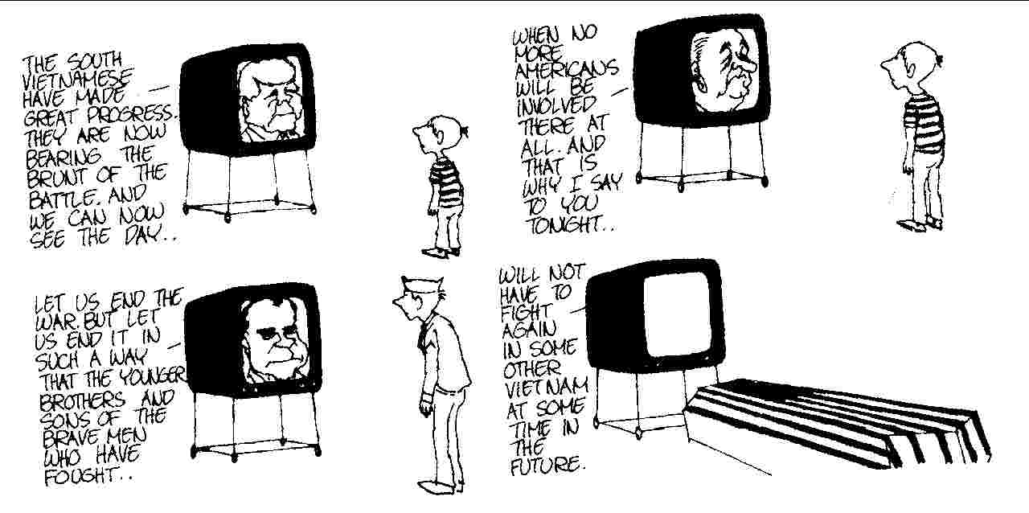
Political Cartoon, By Jules Feiffer (1971)
Organizing Your Ideas
Arguments SUPPORTING the Idea that the US was justified (correct) in going to war in Vietnam
Based on the source materials, list the most important arguments, or points of view, presented to support the idea that the United States was correct in getting involved in the war in Vietnam. Also list the specific evidence that supports each argument.
Put an * next to what you consider to be the strongest argument
Arguments  Supporting that the US was justified | Specific Supporting Evidence From  (Cite Source)

Counterclaim: If you are going to argue that the US was correct in going to war, how would you refute (disprove) the * above?

Organizing Your Ideas
Arguments SUPPORTING the Idea that the US was NOT justified (not correct) in going to war in Vietnam
Based on the source materials, list the most important arguments, or points of view, presented to support the idea that the United States was wrong about getting involved in the war in Vietnam. Also list the specific evidence that supports each argument.
Put an * next to what you consider to be the strongest argument
Arguments  Supporting that the US was NOT justified | Specific Supporting Evidence From  (Cite Source)

Counterclaim: If you are going to argue that the US should NOT have been involved in the war, how would you refute (disprove) the * above?

