Name: _________________________ Period: ________ Date: _______________

Roots of the Vietnam War (1945-1964)

- Where in the World is Vietnam?

- Known as while under French rule
- Geography of Vietnam
- Vietnam is covered with , , .
- An Extremely Brief History of Vietnam

- Ho Chi Minh
- Born: Nguyen Sinh Cong in 1890
- Studied in and worked in .
- Believed in .
- Wanted a .
- Asked the United States multiple times for help against French imperialism…was ignored.
- Ho Chi Minh: Freedom Fighter?
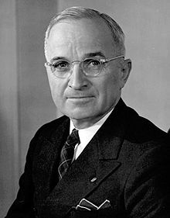
- Ho Chi Minh fought for an independent and united Vietnam against the (during WWII), , and against the .
- Modeled their declaration of independence after the American ,
“We hold the truth that all men are created equal, that they are endowed by their Creator with certain unalienable rights, among them life, liberty and the pursuit of happiness. This immortal statement is extracted from the Declaration of Independence of the United States of America in 1776. These are undeniable truths.” –Excerpt from Vietnamese Declaration of Independence
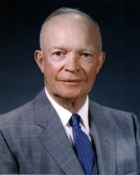
- Geneva Accords (1954)
- Peace agreement that:
  - Divided Vietnam in half
  - Called for free elections by 1956
North Vietnam | South Vietnam

- Ngo Dinh Diem
- President of
- Ignored and did not agree to hold free elections in 1956 (because he knew Ho Chi Minh would win)
- Attacked Communists in South Vietnam
  - Communists responded by forming the
    - Militant supporters of Ho Chi Minh who lived in the South
- The Role of the U.S.
- - A promise that the U.S. would help any nation resist Communist aggression
  - Sent billions of dollars in aid to the South during the 1950s
  - Sent 100s of soldiers to advise and train the South Vietnamese (but not fight)
- - if one country falls to Communism, surrounding countries will fall too (like dominoes)
- Diem and the U.S.
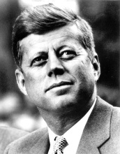
- U.S. pressured Diem to help the South Vietnamese poor in order to make communism less appealing.

- Diem took rights away from South Vietnamese and persecuted Buddhists because they were supposedly .
  - Outcry and protests began against Diem including by Buddhist monks.
- U.S. Withdraws its Support
- By 1963, the U.S. (under Kennedy) no longer supported Diem and his oppressive ways.
- South Vietnamese Army assassinated Diem without U.S. approval.
- U.S. sends an addition 15,000 military advisors to the South as well as navy vessels.
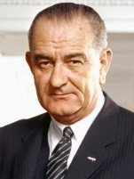
- The Gulf of Tonkin Incident
- U.S.S. Maddox said to have been fired upon by North Vietnamese in the Gulf of Tonkin off the coast of Vietnam.
- President Lyndon Banes Johnson urged Congress to give him approval to defend U.S. interests in Vietnam. Congress approved.

