[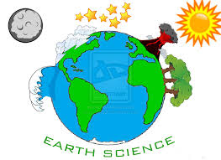](http://www.google.com/imgres?imgurl=http://fc09.deviantart.net/fs71/i/2011/313/9/4/earth_science_design_by_applesduh-d4fg0iu.jpg&imgrefurl=https://sites.google.com/site/httpmsreillyearthscience&h=745&w=1024&tbnid=hRqXhip-CC8xzM:&docid=b4oHgsj1UmPznM&ei=U8ISVrmaBcmTwgT7q7zwCw&tbm=isch&ved=0CCsQMygPMA9qFQoTCPmPoe37q8gCFcmJkAod-xUPvg)