Center for Global Studies
at Brien McMahon High School, an International Baccalaureate World School
300 Highland Avenue, Norwalk, CT
CGS is an Inter-District Magnet High School for International Studies
Specializing in Arabic, Chinese, and Japanese Languages and Cultures

Invites You to Visit Our School
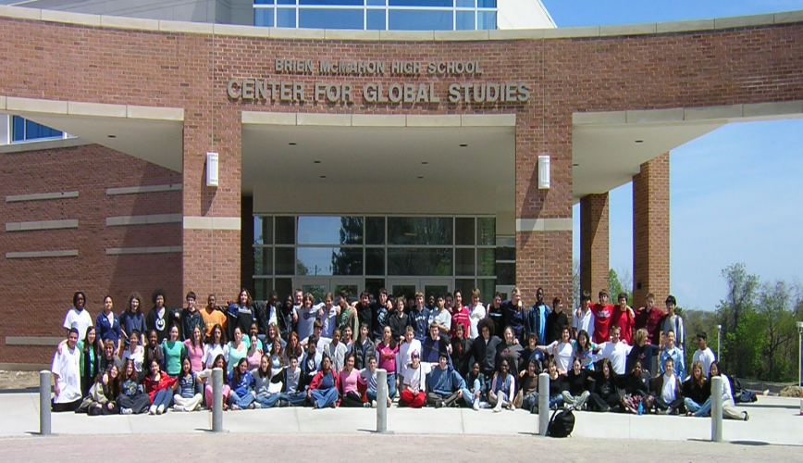

Both Students and Parents are welcome at all sessions.
All sessions take place in the CGS Community Room.

Evening Open Houses

~Meet staff, students, and administrators
~Listen to student presentations
~Learn about our unique, global curriculum and study tour opportunities

6:30 – 8:30 p.m.
Thursday, October 12, 2017
Wednesday, October 25, 2017

Daytime Information Session

~Speak with students
~Gather information
~Visit classes
~Tour our school
~Question and answer period

8 – 10 a.m.
Thursday, November 2, 2017

Please visit our website:
cgs.norwalkps.org

Accepting applications beginning October 1, 2017 for the 2018-2019 school year.
Apply online at cgs.norwalkps.org
All applications must be completed on the website by January 10, 2018.

For directions, or more information about our school, please visit the website: cgs.norwalkps.org
or contact Laurie Cawley, CGS Secretary,
at 203-852-9488, option 2, or CAWLEYL@norwalkps.org

