Informational Session

BRIDGEPORT REGIONAL AQUACULTURE SCIENCE AND TECHNOLOGY CENTER
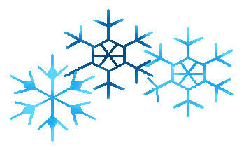
60 St. Stephens Road
Bridgeport, CT 06605
(203) 275-2929

Winter Informational Session date for interested students currently in grades 8 through 11. Students and families from Bridgeport, Fairfield, Stratford, Milford, Monroe, Shelton, and Trumbull School Districts are invited and welcome.

Thursday, January 25, 6:30–7:30 pm.
.

